An empirical study on the challengers faced by SMEs in Sri Lanka in adopting digital technologies and their impact on business performance

PAU Kawya
Management information systems
NSBM Green University
28695

Complete draft Submission Version 01

CHAPTER 01
INTRODUCTION
1.1 Chapter Overview
This chapter introduces the research on "An empirical study on the challengers faced by SME’s in Sri Lanka in adopting digital technologies and their impact on business performance". It sets the groundwork for the study by providing the background on the research, present-day digital transformation scenario and the problems associated with the SMEs' digital technology adoption.
While digital transformation is crucial to the success of SMEs in terms of competitiveness and sustainability, many companies still face technological, organizational, financial and environmental challenges that prevent them from effectively using digital solutions. Therefore, the importance of understanding digital readiness and recognizing these barriers is transforming into a key focus in helping SMEs on their digital transformation journey.
The chapter starts with problem background which explains the significance of SMEs to the economy of Sri Lanka, and the growing need of digital technologies in business operations. It also outlines the current obstacles in the way of digital technology uptake, such as the lack of digital skills, technological infrastructure, lack of funds and concerns about cybersecurity. The context of these issues provide an understanding of the research problem and highlights the need for practical digital transformation support mechanisms.
After the background, the chapter states the problem statement which is broken down into the general problem and specific problem. The general problem elaborates on low digital adoption among SMEs whereas the specific problem points out the gap in the literature by highlighting the lack of an integrated platform for assessing digital readiness, identifying digital barriers, the measurement of business performance, and the provision of practical suggestions for the improvement. The chapter then constructs the research question that is used to guide the entire research, then follows it with the research motivation, research aim and research objectives which determines the direction and expected outcome of the research.
In addition, the proposed web-based decision support platform is introduced, and a rich picture is used to show the overall workflow of the platform. The platform also combines several functional modules such as the registration of SMEs, business-type specific assessments, dashboard visualization, lightening of inventory and sales management and a rule-based recommendation engine for assisting SMEs in enhancing their digital capabilities. Finally, the chapter outlines the required resources, the scope of the project of what functionalities are in and out of scope and summarizes the chapter by transitioning to the literature review as presented in Chapter Two.

1.2 Problem Background
1.2.1 Importance of SMEs and Economic Contribution
Small and Medium Enterprises (SMEs) are seen as a significant contributor of economic development in developed and developing countries. SMEs play an important role in creating jobs, developing entrepreneurship, innovation, reducing poverty and stimulating regional economic growth. SMEs play a significant role in the Sri Lankan business landscape and are crucial in driving the economy through job creation and fostering entrepreneurship. SMEs contribute significantly to economic development and business opportunities in various sectors in Sri Lanka, according to the National Enterprise Development Authority (NEDA) [1].
However, many Sri Lankan SMEs are still facing challenges in their operations that hinder their competitiveness and sustainability. Some of the constraints are limited financial resources, absence of a skilled workforce, no access to sophisticated technologies and challenges in adapting to the fast-changing business landscape. The world is increasingly digital, and SMEs must enhance their technological skills to remain competitive and make a path for sustainable growth.

1.2.2 Digital Transformation and Its Importance for SMEs
Information and communication technologies have greatly transformed the way business is conducted. Digital transformation is defined as the approach of introducing digital technologies into business processes, business structures and value creation activities for the purpose of increasing efficiency, customer satisfaction and competitiveness of the businesses [14]. Digital transformation is more than just a simple technology adoption – it's a shift in business operation, decision making, customer engagement and business value.
Organizations have opportunities to enhance productivity and operational efficiency through adopting modern digital technologies like cloud computing, Enterprise Resource Planning (ERP) systems, e-commerce platforms, digital payment solutions, Customer Relationship Management (CRM) systems, and business analytics tools. These technologies can help organizations streamline their manual tasks, make information easier to access, lower operating expenses, and enable data-driven decision-making [2] and [14].
While large companies have been able to implement a lot of digital technologies, SMEs may have problems reaching the same level of digital transformation. Generally, large organizations will have an IT department, more funds available for investment, and a digital strategy. SMEs, on the other hand, generally have smaller budgets, smaller workforce, and lower technical skills, making it difficult to adopt and manage digital technologies.

1.2.3 Challenges of Digital Technology Adoption Among SMEs
There are a number of technological, organizational and environmental factors that affect the adoption of digital technologies by SMEs. Technology–Organization–Environment (TOE) framework, developed by Tornatzky and Fleischer, states that three major dimensions impact technology adoption decisions including technological, organizational, and environmental factors [10].
Technological dimension includes factors like the availability of technology, technology complexity, compatibility and suitability for business needs. The organizational dimension is related to the internal capabilities, such as financial resources, employees' skills, management support, and organizational readiness. The environmental dimension takes account of external factors that include competitive pressures, customer expectations, government support and industry conditions.
Baker also clarified that organizations do not adopt technologies simply because they are available because the organizational resources and capabilities are required to implement the technologies and use them successfully [17]. In the same way, Thong found the owner-manager characteristics, organizational resources and technological knowledge to have an impact on the adoption of SME information systems [11].
This means, for digital transformation to be successful, digital tools need to be put in people's hands but it's not enough. SMEs should be ready, aware and strategic in adopting appropriate technologies and incorporating them into their processes successfully.

1.2.4 Digital Transformation Challenges in Sri Lankan SMEs
Despite its potential, digital transformation continues to be difficult for SMEs in developing nations like Sri Lanka because of a number of economic and organizational impediments. Even though a lot of new technologies are available, lots of SMEs continue to make use of old business strategies like manual record keeping, paper-based documentation and informal decision making processes. While they can work for small-scale businesses, they make it harder to scale, keep businesses out of sight and out of mind, and make it difficult to make data-driven decisions.
Several barriers to technology adoption have emerged from recent studies carried out from the Sri Lankan SME context. Lasanthika and Pavithra concluded that the adoption of technology has a positive impact on the organizational performance of SMEs in Sri Lanka, but there are many SMEs that are still facing challenges because they lack the technological knowledge, resources, and implementation issues [7].
In the same way, Yazeer and Sachithra identified that both technological, organizational and environmental factors play significant role in the adoption of technology in the Sri Lankan SMEs. They identified that organizational readiness, management commitment and external support were key factors to making a successful digital transformation [6]. The challenges show that many SMEs are aware of the benefits of digitalization, but do not know how to guide themselves towards the right technologies for their business needs and how digital investments can deliver value to their business.

1.2.5 Digital Readiness and Its Role in SME Transformation
Digital readiness is now a key theme in the understanding of an organization’s ability to successfully implement and use digital technologies. Digital readiness means the capacity of an organization to embrace, adopt and successfully leverage digital technologies to meet business goals. Being "digital ready" is not just about technology. It is comprised of several dimensions such as:
- Technological readiness – availability of digital infrastructure, systems, and connectivity.
- Financial readiness – ability to invest in digital solutions and maintain technology resources.
- Digital skills readiness – availability of employees with sufficient digital knowledge and technical skills.
- Strategic readiness – management commitment and planning capability for digital transformation.
- Cybersecurity readiness – ability to protect digital assets and business information.
Multiple factors that influence the capability of digital transformation in SMEs were identified by Okfalisa et al. and a digital readiness assessment approach was proposed. Their research pointed out that analyzing digital readiness enables organization’s to get an understanding of their current state of digital readiness and pinpoint areas that need to be developed before they can implement digital solutions [15].
Moreover, Okfalisa et al. introduced a decision support method for assessing SME readiness to digitalize using various influencing factors from various perspectives [16]. The studies show that a structured assessment of digital readiness can be beneficial for SMEs and help them to make informed decisions on digital transformation.

1.2.6 Impact of Digital Transformation on SME Business Performance
The connection between digital transformation and business performance is deeply intertwined as the successful implementation of digital transformation can lead to enhanced operational efficiency, productivity, customer engagement, and decision-making processes. Digital systems can help SMEs with inventory management, sales monitoring, financial analysis, customer relationship management and business planning.
Adopting technology isn't enough, though, to guarantee digital transformation's benefits. Organizations must be ready, have the necessary skills, and adopt proper strategies for successful digital transformation to effectively leverage digital solutions. So, it is critical to grasp the connection between digital readiness, digital barriers and business performance to design good and sound SME transformation strategies..

1.2.7 Digital Transformation Initiatives and SME Support in Sri Lanka
Sri Lanka has initiated various programs to increase the level of digital adoption within businesses, especially SMEs, due to the significance of the digital transformation. Technology adoption and innovation capability as a key determinant for improving the competitiveness of SMEs has been identified by government institutions, like the National Enterprise Development Authority (NEDA) [1].
Digital economy initiatives promote the use of digital communication tools, websites, electronic payments and other digital solutions by companies. Most of the current support programs, however, are limited to raising awareness and encouraging the use of technology, but do not offer personalized assessment and decision making support. To help many SMEs understand their current level of digital maturity, and identify what they need to do to improve. Thus, technology availability is not enough without adequate assessment tools and decision support tools to support SMEs.

1.3 Problem Statement
The digital revolution is a key driver in today's business landscape to drive organizations to enhance their efficiency in the workplace, delivering better customer experience, supporting data-driven decisions and staying competitive. Digital technologies, including cloud computing, digital payment systems, enterprise applications and business analytics, help organizations enhance their business processes and identify new opportunities for growth [5].

Despite the many advantages of digital transformation, SMEs grapple with many challenges when implementing digital technologies, versus larger organizations. Financial, technological infrastructure, digital skills, organizational readiness and technological change resistance are the different aspects that may negatively affect the successful implementation of digital transformation initiatives for SMEs [3].

SMEs are important contributors towards employment creation, income generation and business activities contributing to economic development in Sri Lanka. But there are still a number of businesses in Sri Lanka that are relying on conventional business methods, manual processes and limited digital solutions. These constraints make it less efficient and facilitate fewer business expansion opportunities and impact on their competitiveness in a digitalized world.

Previous studies have examined the factors that influence the adoption of digital technology in SMEs by applying technology adoption models [10, 11, 13] including the Technology–Organization–Environment (TOE) Framework, Diffusion of Innovations (DOI) Theory and SME information technology adoption models. Most of the current research, however, tends to focus on discovering what factors affect adoption, and not offer practical solutions that help SMEs assess their digital readiness and choose appropriate digital transformation strategies.

Moreover, the current methods for assessing digital readiness primarily restrict themselves to quantifying technological readiness but offer little assistance in the continuous monitoring of technological readiness, in the business performance assessment, and in drawing out personalized recommendations for development [15] and [16]. Hence, Sri Lankan SMEs need a readily available and easy-to-use decision support tool that can assess their digital readiness, uncover the challenges, and offer suggestions for thriving in the digital world.

Therefore, this research concentrates on the creation of a web-based Digital Readiness Assessment and SME Support System that can help SMEs understand their level of digital maturity and pinpoint the challenges of technology adoption for them to make appropriate decisions about digital transformation.

1.3.1 General Problem
Digital technologies have revolutionized business operations with the advancement of communication, automation, customer relationship management and decision-making. Adopting digital technologies effectively can enable organizations to have better productivity, flexibility in operation and sustainable competitive advantages [14].

Yet, there are many SMEs that are still struggling with digital technology adoption because of restricted financial means, a lack of technical skills, low levels of employee digital skills and doubts about the potential advantages of digital transformation [3]. Compared with large organizations, SMEs normally have limited resources to allocate to the development of advanced technologies, building of IT infrastructure, and employing specialized technical personnel [4].

The lack of appropriate digital technologies poses multiple business challenges for SMEs such as inefficient business processes, inadequate information management, restricted market access and challenges in meeting evolving customer expectations [5]. In developing economies, these problems are greater as the SMEs are more likely to be resource-constrained and to not have a structured digital transformation approach [3].

The Sri Lankan scenario poses further constraints on SMEs including economic instability, financial resource limitation, lack of awareness on technology and problem on acquiring digital skills. All these factors negatively affect the capacity of SMEs to make good use of digital technologies and increase their organizational performance [6].

Hence, the importance of increasing the digital readiness of SMEs beyond just growth; it is equally important to enhance the competitiveness and economic development of a country. To ensure the SMEs can identify their existing digital competences, their adoption barriers, and what they should do to engage in digital transformation, a systematic approach is necessary.

1.3.2 Specific Problem
While several frameworks have been developed to explain the factors that influence the technology adoption, these frameworks were developed to explain the adoption of technology but not provide any practical tools for the SMEs to manage their digital transformation process [10, 11, 13, 17] such as the Technology–Organization–Environment (TOE) Framework, Diffusion of Innovations Theory, and integrated SME IT adoption models.

Previously, some digital maturity assessment studies developed methods to assess the digital maturity of SME and to identify the factors to be considered in digital adoption. For instance, the evaluation of readiness level of the SMEs has been suggested with the help of a structured model and analytical approach [15] and [16]. However, there are a number of approaches already in place which are primarily research-based, and are not comprehensive enough as a package to include readiness assessment, business performance evaluation, recommendations and progress monitoring.

Moreover, most of the existing digital business solutions like digital management tools, business intelligence platforms and enterprise resource planning systems are tailored primarily for organizations that possess a larger financial capability as well as technical expertise. These solutions can be quite complicated and are too expensive to implement and maintain in a small business [8].

Business owners in Sri Lanka are not aware about the appropriate technology and lack the ability to identify which digital solution suits their business needs, making simple, affordable and user-friendly digital support systems particularly important for SMEs. If left unguided, SMEs can invest in wrong technologies, or miss on important areas that need improvement.

So, a large gap exists between what people are researching on digitization and what they are actually doing. Current approaches are not enough to offer SMEs a system which can not only assess digital readiness, but also identify the barriers for technology adoption, evaluate business performance, provide recommendations and facilitate decision-making through an interactive platform.

In response to this, this research aims to develop a web-based Digital Readiness Assessment and SME Support System incorporating readiness assessment, Composite Mean Index (CMI) scoring, Rule Based Recommendation Generation and Dashboard visualization. The proposed system will give SMEs a practical approach and suggestions on how to make more work to be more ready to digital transformation and boost business performance.

1.3.3 Survey Response Analysis and Discussion
1. Purpose of the Survey Analysis
A preliminary analysis of the questionnaire's answers was done to see if there is any relationship between problems identified in literature and the problems encountered by the SMEs that have been surveyed. The analysis was based on the following focus areas: Current use of digital technologies, Digital Readiness, Digital barriers, and Business performance. The results of the study serve as empirical evidence to identify the research problem and the need for the proposed SME Digi platform.

2. Summary of Key Survey Findings
Table: Summary of Key Survey Findings

Survey Area | Key Finding | Result | Problem Indicated
Digital Tool Usage | Most surveyed SMEs use some form of digital technology | 71.9% | Digital-tool usage exists, but it does not necessarily indicate complete digital readiness
Infrastructure Readiness | Lowest readiness dimension | CMI = 2.50 | Weak technological infrastructure can restrict digital transformation
Strategic Readiness | Moderate readiness | CMI = 3.26 | Digital adoption is not always supported by strong strategic planning
Cybersecurity Readiness | Moderate readiness | CMI = 3.13 | SMEs require greater cybersecurity preparedness
Digital Barriers | SMEs experience notable barriers to digital adoption | Overall Mean ≈ 3.29 | Adoption is affected by multiple internal and external constraints
Cybersecurity Concerns | Strongest individual barrier | Mean = 4.22 | Security concerns can restrict effective digital adoption
Business Performance | Generally positive perceived outcomes from digital adoption | Overall Mean ≈ 3.68 | Digital adoption has perceived business value, strengthening the need to improve SME readiness

3. Discussion of the Findings
The preliminary survey findings corroborate the research problem formulated from the literature. While 71.9% of the surveyed SMEs are already using digital tools, the results show that they vary according to the different dimensions of digital readiness. Infrastructure Readiness had the lowest score at 2.50, whereas the Strategic Readiness (3.26) and Cybersecurity Readiness (3.13) were moderate. This means reliance on digital technologies does not necessarily mean the organization is ready for digital transformation.
The barrier analysis also shows that there are constraints which can impact on the successful uptake of digitalization for SMEs. The mean of the barrier for Cybersecurity was the highest at 4.22, and the general barrier mean was around 3.29. Concurrently, the Business Performance items had an overall mean of around 3.68 which were generally well perceived in relation to the outcomes of the adoption of digital. The results highlight that Digital Readiness, Digital Barriers and Business Performance should be looked at in concert, and not as Digital adoption alone.

4. Link to the Proposed SME Digi Platform
Hence, the results of the survey can be used as further evidence of the research topic and the creation of the SME Digi. The differences found in readiness and barriers are relevant to the need for a Digital Readiness, Digital Barriers and Business Performance assessment, as well as a set of rules that drive a recommendations mechanism that gives the right advice for improvement. The relationship between the findings on the questionnaire, the research objectives, and the system requirements is presented in detail in Chapter 4 under Operationalization Process.
1.4 Research Question
Main - How do digital adoption challenges and digital readiness influence the business performance of SMEs in Sri Lanka?
- What are the key digital challenges for the digital transformation of SMEs in Sri Lanka?
- What is the current level of digital readiness of SMEs in the main dimensions of digital readiness, such as infrastructure, finance, skills, strategy, and cyber security?
- How will digital readiness affect digital barriers, and how will these affect business performance in SMEs?
- How can a rule-based recommendation engine generate customized digital transformation strategies based on composite assessment scores?
1.5 Research Motivation

This study was inspired by several observations. In the preliminary survey of the business practices of the SMEs conducted in Sri Lanka the researcher noticed that most of the owners and managers of the SMEs were not aware of the status of their organization's digital readiness. They recognized the need for digitization, but they didn't have a structured tool that was affordable to help them assess where they were on the spectrum of digitization. This practical lack of awareness directly led to the use of development of an assessment-oriented platform.
Second, the literature review provided an insight into possible theoretical background that can be applied to the case of SME technology adoption, including such frameworks as TOE [10], Rogers’ diffusion of innovations [13] and Thong’s SME IT adoption model [11]. However, it becomes clear that the majority of theories and models are aimed at providing an understanding of factors that predetermine the adoption of technology in a certain environment, not on developing an integrated platform for assessing and making a choice between available options. Therefore, the need for creating SME Digi is important.
Third, the context of Sri Lanka's development journey in becoming a middle-income country where digital economy is emerging is relevant and timely. The Government is making a commitment to digitalization of SMEs through national strategies (National Digital Economy Framework) and national institutions (National Enterprise Development Authority (NEDA) SME development initiatives). But the tools that are available for assisting SMEs in this transition are still limited [9]. These national priorities are directly addressed and provided support by the proposed SME Digi platform.

1.6 Research Aim
The research objective is to design and develop a web-based decision support platform (SME Digi) which can help the SMEs in Sri Lanka to evaluate their digital readiness in five key dimensions of digital transformation, identify digital transformation barriers, check their business performance indicators and will provide automated, rule-based recommendations for their digital transformation journey. The platform also comes with a lightweight inventory and sales system to add as an evaluation tool and as a true business support tool.

1.7 Research Objectives
1.7.1 To Identify
To conduct a systematic review of existing literature and theoretical frameworks to identify significant digital barriers impacting SMEs in Sri Lanka and the critical dimensions of digital readiness in the Sri Lankan SME environment.
1.7.2 To Analyze
To conduct an analysis of the digital readiness, digital barrier, and business performance indices that have been derived through the questionnaire using descriptive statistics and Composite Mean Index calculation.
1.7.3 Design and Develop:
To create and implement the SME Digi web-based platform with PHP and MySQL as the back-end technology, and a responsive front-end, including SME registration, digital readiness assessment, barrier assessment, sales and inventory management and an interactive dashboard visualization module(admin/user).
1.7.4 To Evaluate
To evaluate the developed SME Digi platform through functional testing to determine whether the implemented functions operate according to the defined system requirements

Stage | Workflow Description
Stage 1 | SME Registration: Business owner registers the organization with basic details including business name, sector, employee count, and annual revenue bracket. A secure login account is created.
Stage 2 | Digital Readiness Assessment: The SME completes a structured Likert-scale questionnaire covering five dimensions — Infrastructure Readiness, Financial Readiness, Digital Skills and Workforce, Strategic Readiness, and Cybersecurity Preparedness. Mean scores per dimension are calculated.
Stage 3 | Digital Barrier Assessment: A parallel questionnaire measures the severity of digital barriers across financial, technical, organizational, and environmental categories.
Stage 4 | Business Performance Evaluation: Key business performance metrics, including revenue trends, customer growth, and operational efficiency indicators, are captured.
Stage 5 | Recommendation Engine: A rule-based engine evaluates composite scores against predefined thresholds and generates targeted, category-level improvement recommendations.
Stage 6 | Dashboard Visualization: An interactive dashboard presents assessment results through charts, score cards, and comparison tables. SMEs can track score progression over time.
Stage 7 | Business Management: Lightweight inventory and sales management modules allow SMEs to record stock, transactions, and generate basic reports.

1.8 Rich picture of the proposed solution.

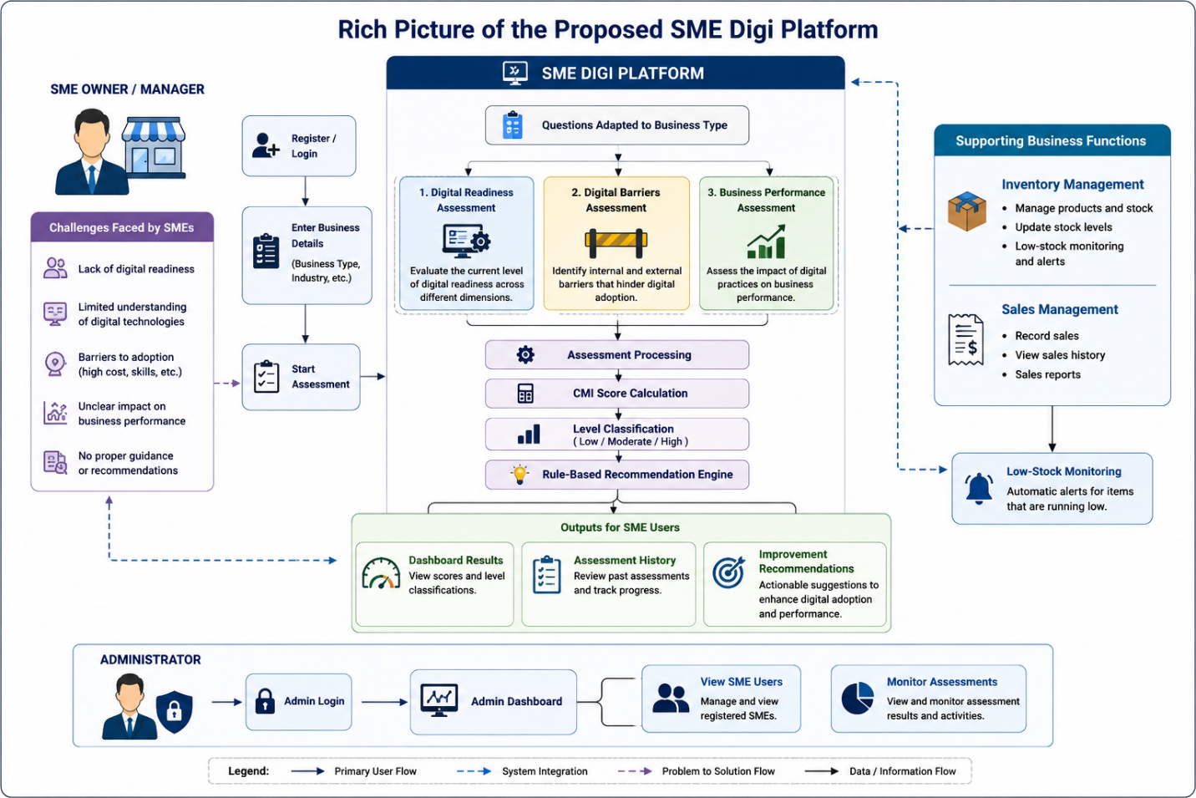

The rich picture presents the entire flow of the proposed SME Digi platform, and how it can assist SMEs in the assessment process, decision making and basic business management. The following is an explanation of the main workflows.

1.SME Registration and Business Profile Flow
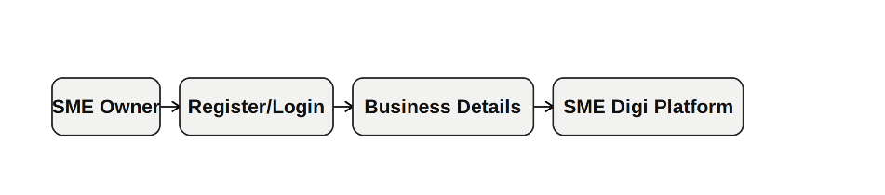
The owner or manager of the SME registers and enters the general information about the business, such as the nature of the business. Questions are presented according to the selected type of business, based on the SME's business context.

2. Assessment Flow
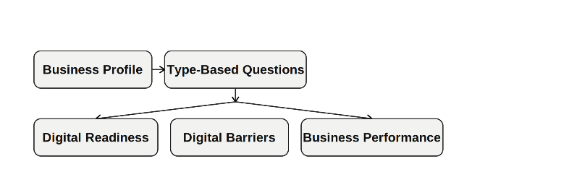
The SME user will take 3 different assessments. Digital Readiness assesses the readiness of the organization to digitalize; Digital Barriers helps identify factors that could impede digitalization; and Business Performance assesses relevant business outcomes..

3. Assessment Processing Flow
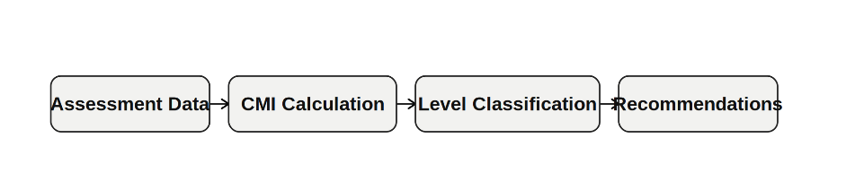
The system then processes the answers submitted and produces the appropriate CMI scores. The results fall within pre-defined ranges (Low, Moderate, High). The assessment results are then fed into the rule-based mechanism which, based on the rules, can provide appropriate recommendations.

4.Results and Recommendation Flow
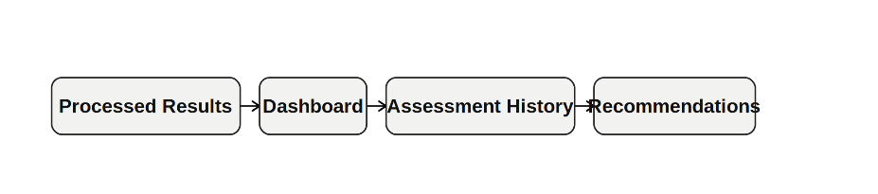
The SME user will have access to the dashboard which will display the scores and classification of the assessments and can see the results of the previous assessments; the SME user will also be provided with practical suggestions on how to improve the weaker areas.

5.Business Management Flow
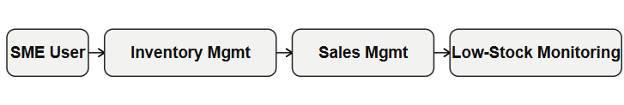
Lightweight business-support functions are also available with SME Digi. Users can keep track of stock, make sales, view sales date, and determine which items are running low.

6.Administrator Flow
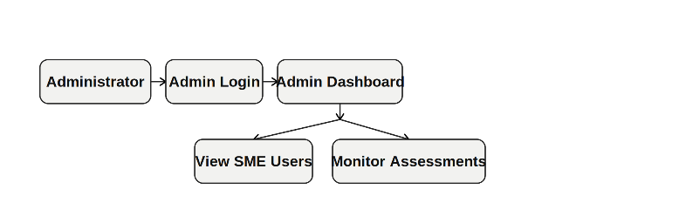
The administrator has his own administrative console. The administrator is able to use the Admin Dashboard to see registered SME users, track assessment results and related activities.

1.9 Resource Requirements

1.9.1 Hardware
Development Machine: Personal laptop / desktop computer
Web Server: local (XAMPP - Apache + MySQL)
• Client Access: Mobile-friendly and can be accessed by any device with a web browser and internet connection

1.9.2 Software
• Backend: PHP, MySQL
• frontend: JavaScript (React.js via Vite) + JSX, HTML, CSS
Development Environment: XAMPP, VS Code
Track changes in files and projects. Use Version Control: Git and GitHub.
Dashboard visualizations: Chart.js
Testing: Manual UAT using browser developer tools.

1.10 Project Scope
The following inclusion/exclusion boundaries are used for defining SME Digi:

In Scope | Out of Scope
SME registration and authentication system | Advanced ERP functionalities (HR, payroll, MRP)
Digital readiness assessment (5 dimensions) | Machine Learning or AI-based recommendation models
Digital barrier assessment questionnaire | Large enterprise or multi-branch management
Business performance evaluation module | Financial accounting and tax management
Rule-based automated recommendation engine | Third-party e-commerce integration
Interactive dashboard with visualization | Mobile application (Android/iOS)
Basic inventory and sales management | SMEs outside Sri Lanka or large enterprises

The platform aims specifically to benefit SMEs in Sri Lanka, in various sectors, such as retail, manufacturing, service, industry and agribusiness. The system is designed to be used by non-technical SME owners/managers, who do not need to know how to use IT.
1.11 Chapter Summary
The purpose of this chapter was to provide a background for the research by articulating the key issues of digital transformation that is being faced by the SMEs in Sri Lanka, based on the national development concerns and international academic research. The problem was presented in general and domain specific perspective with a clear research gap, which is there is no integrated, affordable, web based platform for digital readiness assessment, problem identification and automated recommendation generation for Sri Lankan SMEs. A research question, a research aim and four structured objectives were formulated, and then a rich picture of the proposed SME Digi solution in terms of a workflow was developed. The requirements for the resources and the scope limits were identified to inform the rest of the system design and development. The next chapter is a systematic review of the literature which further validates the identified research gap and provides a theoretical and technical background for the platform.

CHAPTER 02
LITERATURE REVIEW
2.1 Chapter Overview
This chapter discusses the extensive literature review pertinent to the research problem. The review is organized thematically, so that the reader is introduced to the various aspects of the proposed SME Digi platform, starting from the basic level of general domain knowledge, and then moving on to the theoretical and technological aspects. The chapter starts with a conceptual map of literature and then an overview on the concept of a digital transformation of SMEs. Theories, frameworks, systems and related approaches that have been developed are subsequently compared to determining their applicability and weaknesses in meeting the research problem.

The chapter then provides a technological analysis on assessment and scoring mechanism, system design approaches, rule-based recommendation mechanism and workflow aspects related to SME Digi. Lastly, the literature reviewed is critically reflected on to determine the research gap and the need for the creation of the proposed SME Digi platform.

The reviewed literature can be divided into four groups of topics, namely (1) theoretical foundations of technology adoption (TOE Framework [10], SME IT Adoption Model [11] and Diffusion of Innovations theory [13]); (2) studies on digital transformation of SMEs in developing and emerging economies [3],[6]; (3) studies on technology adoption and digital transformation in SME context in Sri Lanka [6], [7], [9]
and (4) technological approaches to digital-readiness assessment and decision-support systems (assessment dashboards and rule-based decision-support systems [15],[16] and [21]).

2.2 Conceptual Map of literature
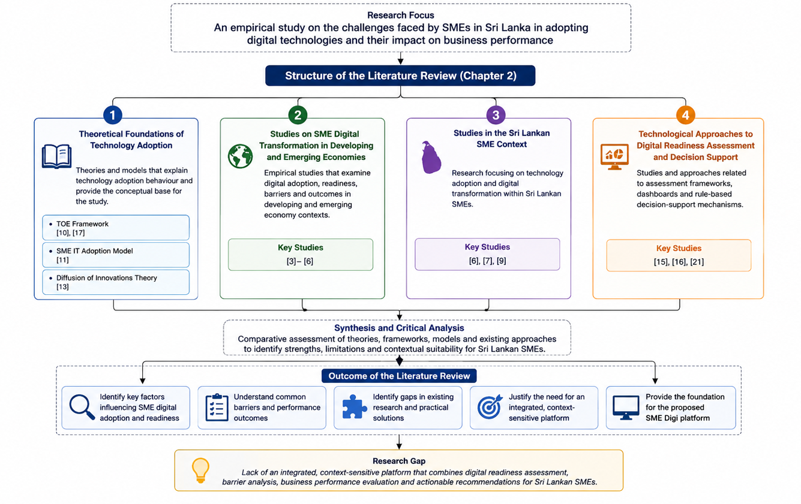

In the above Figure, organizes the reviewed literature into four main thematic areas. The first area is related to the theory of technology adoption such as the TOE Framework, SME IT Adoption Model, and Diffusion of Innovations theory [10, 11, 13, 17]. The second looks at the digital transformation of SMEs in developing and emerging economies [3]– [6] and the third at studies specifically concerning the adoption of technology and digital transformation of SMEs in Sri Lanka [6]–[7] and [9]. The fourth area, "Technological approaches to digital readiness assessment and decision-support systems", is examined in [15], [16] and [21].

These areas form a theoretical, contextual, and technological basis for the study. The literature is comparatively analyzed to identify the existing limitations and to set the research gap for the development of the proposed SME Digi platform.

2.3 Domain Overview

The term digital transformation is used to describe ways that organizations fundamentally change the way they operate, the culture they foster, and how value is delivered by the use of digital tools [14]. The concept of digital transformation was one of the most widely cited conceptualizations by Vial et al. (2019), which defines it as 'a process that aims to improve an entity by triggering significant changes to its properties through combinations of information, computing, communication, and connectivity technologies' [14]. This is a very general definition that can be used by any business size, but the paths to implementing it are very different between large companies and SMEs.
In most economies, SMEs are the predominant type of business. SMEs are around 75 percent of all businesses accounting for around 45 percent of GDP and more than 52 percent of total employment in Sri Lanka [1]. However, while SMEs are important to the economy, they have generally been observed to lag behind large businesses in their digitalization, irrespective of their use of digital tools, across Sub-Saharan Africa, South and Southeast Asia, and Latin America [3]. The Sri Lankan government has acknowledged such a gap in the implementation of several national digital development initiatives, but structural and resource barriers still hinder implementation at the ground level [9].
The readiness to successfully adopt technologies has become a key prerequisite: digital readiness, which is an organization's readiness for digital transformation. This concept has been given various dimensions by scholars. Based on what Oliveira and Martins (2011) managed to establish, there are three key factors in the adoption of IT at the firm level: technology characteristics, organizational capacity, and environment context [2]. These dimensions are closely related with the TOE Framework which serves as a theoretical basis for the present research.

2.4 Existing Systems, Frameworks, and Designs

2.4.1 Technology–Organization–Environment (TOE) Framework
The TOE Framework is proposed by Tornatzky and Fleischer (1990) that the factors influencing the adoption of technology at the firm level are three contextual factors: (1) technology context, available technologies relevant to the firm; (2) organizational context, firm size, managerial structure, and internal resources of the company; and (3) environmental context, market forces, competition, and regulatory environments [10]. The framework has been broadly used in information systems research and proven to have high applicability to the case of adoption of digital in SMEs.
The TOE Framework has been extensively used in information systems research to account for information technology adoption in organizations. It is important to consider its technological, organizational and environmental context especially for SMEs, whose technology adoption decisions are affected not only by technologies available, but also by the organizational resources and the external environment [10], [17]. But, TOE is not an assessment instrument for self-evaluation for the SME owner and/or manager but is an explanatory theoretical framework. Hence, in this research, the framework has been selected as the theoretical basis for identifying the elements that are important and the concepts have been translated into assessment scales that can be measured in the proposed SME Digi platform.

2.4.2 SME IT Adoption Model (Thong, 1999)
Thong's SME IT Adoption Model is an important theoretical perspective for understanding information technology adoption in small businesses. The model is based on the hypothesis that the attributes of the organizational decision-maker, technological attributes, organizational attributes and environmental factors can affect the adoption of IT in small organizations [11]. Especially for SMEs, technology decisions are often made by a few key individuals within the organization.
The model works alongside the TOE Framework by emphasizing characteristics that are particularly relevant within small-business environments. The success of SMEs in implementing information technologies may be affected by the knowledge level and innovativeness of decision makers, organizational resources, information system characteristics and external conditions [11].
Thong’s model, despite being a valuable theory on IT adoption in small business, was mainly developed to explain factors that lead to the adoption of IT rather than to offer SMEs an operational digital-readiness self-assessment system. Hence, the concepts developed from the model are in line with the theoretical aspect of this research, and the SME Digi can be used in the actual assessment and decision-making process.

2.4.3 Diffusion of Innovations Theory
The Diffusion of Innovations (DOI) Theory is established by Rogers and is related to the adoption and spread of time of innovation or technology [13]. According to Rogers, the five factors affecting adoption are relative advantages, compatibility, complexity, trialability, and observability. These attributes are a primary reason that organizations might think that some digital technologies are more easily adopted, more appropriate or more effective than others [13]. DOI is relevant to SME digital transformation because when considering digital adoption, the SME owners and managers can consider the expected benefits, suitability, complexity and usability of technology.
Such perceptions may affect the readiness of SMEs to adopt new technologies in their business processes. In this regard, DOI offers an additional theoretical framework to study digital technology adoption in SMEs. Nonetheless, DOI is not used as a separate framework of evaluation or computation in SME Digi but serves as an additional theoretical framework along with the TOE Framework and SME IT Adoption Model.

2.4.4 Comparative Assessment of Existing Approaches.
A review of commercially available platforms reveals several gaps in serving the Sri Lankan SME context:

Existing Approach | Main Contribution | Limitation in Relation to SME Digi | Relevance to Research
TOE Framework [10], [17] | Explains technology adoption through technological, organizational, and environmental contexts | Primarily theoretical and does not itself provide an operational SME self-assessment platform | Provides theoretical factors relevant to digital readiness and barriers
SME IT Adoption Model [11] | Explains IT adoption factors specifically within small businesses | Focuses on explaining adoption rather than providing an integrated assessment and recommendation system | Provides SME-specific theoretical support
DOI Theory [13] | Explains how characteristics of innovations influence their adoption and diffusion | Does not provide an organizational digital-readiness scoring or decision-support mechanism | Supports understanding of SME technology-adoption behaviour
Okfalisa et al. [15] | Introduces an intelligent dashboard decision-support approach for assessing SME digital readiness | Focuses primarily on digital-readiness assessment and does not address all functions proposed within SME Digi | Demonstrates the applicability of dashboard-based readiness assessment
Okfalisa et al. [16] | Examines multiple factors influencing SME readiness toward digitalization using a decision-support perspective | Developed within a different contextual setting and does not provide the complete integrated functionality proposed for SME Digi | Supports multidimensional readiness measurement and decision support
SME Digi – Proposed | Integrates Digital Readiness, Digital Barriers, Business Performance, rule-based recommendations, dashboard visualization, and basic inventory/sales support | Designed specifically within the defined scope of this research | Addresses the identified research and practical gap

The comparative analysis reveals that the theoretical frameworks available so far offer useful explanations for technology adoption and that previous digital readiness studies confirm multidimensional approaches to assessment and decision support in the field of technology adoption. However, none of the reviewed approaches individually provides the complete combination of assessment and decision-support functions proposed within SME Digi. The proposed platform hence combines the theoretical constructs, multi-dimensional assessment, scoring, rule-based recommendations, visualization and elementary supporting business functions in a single web-based platform designed for the context of Sri Lankan SMEs.

2.5 Technological Analysis
2.5.1 Algorithmic Analysis

The SME Digi platform proposed needs a clear way of transforming the answers to the questionnaires in to meaningful assessment results and recommendations. The platform is not an Artificial Intelligence (AI) or Machine Learning (ML) solution but rather a structured scoring approach combined with pre-defined decision rules. This is suited to use because the assessment results are repeatable and recommendations can be linked back to pre-determined conditions.
There are three primary assessment areas: Digital Readiness, Digital Barriers and Business Performance. Digital Readiness is measured on five pillars: Infrastructure Readiness, Financial Readiness, Digital Skills and Workforce, Strategic Readiness, and Cybersecurity Preparedness. Financial, Technical, Organizational, and Environmental barriers are used to assess Digital Barriers. The assessment of Business Performance is done by implementing the performance-related indicators that are determined in the research instrument.
A five-point likert scale is used for questionnaire items. Each relevant assessment dimension is summarized by a response using a calculation based on a Composite Mean Index (CMI):
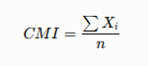

where Xi is the score given to the item i of the questionnaire and n is the number of the items of the questionnaire included in the corresponding assessment dimension.
The calculated scores are interpreted using predefined classification ranges that enable the assessment results to be categorized into understandable levels. Digital Readiness scores show the relative readiness level for each dimension assessed, and Digital Barrier scores are relative to the barrier to a digital transformation, the higher the score, the higher the barrier. The Business Performance scores are indicators of the performance outcomes that are measured by the questionnaire items.

Score | Indicator
1.00-2.49 | Low
2.50-3.49 | Medium
3.50-5.00 | High

The effectiveness of the multidimensional measurement and decision support approaches to assess SME readiness for digitalization is supported by previous studies [15], [16]. In the case of SME Digi this is extended by a predefined rule-based recommendation mechanism, which is linked to the assessment result.
The recommendation mechanism analyzes the resulting scores and determines the dimensions, which need more consideration. The predefined conditions are then correlated with specific recommendations for improvement. Decision-support mechanisms can be conveniently obtained through rule-based approaches, which allow to have a clear idea of the outputs that are generated from given conditions [21]. This places the approach well suited for SME Digi as there is no need to use complex or opaque AI/ML models to produce the recommendations.

2.5.2 Design Analysis
A web-based decision-support system design needs to have some separation between the user interface, application processing, business logic, and data management. With a separation of system responsibilities, systems are more maintainable and different sections of an application can be developed and changed without causing unnecessary impact on the rest of the system. The separation-of-concern principles are well-used in web-application architecture to structure the presentation, processing and data-related functions of the system [22].
SME Digi's system is deployed in a web application consisting of a React.js client-side application, PHP based server side API, and a MySQL relational database. The frontend offers the interfaces needed for the registration of SMEs, the completion of the assessment, visualization of the dashboard, inventory and sales management, and administrative functions. The backend performs login, requests, validation and assessment processing, score computation, rule-based recommendations and interaction with the database.
Structured data is stored in the database and comprises user profiles, SME profiles, assessment questions, assessment answers, calculated output, inventory information, and sales information. A relational database approach is suitable as the platform includes several entities tied to each other and it is necessary to have structured storage and consistent retrieval.
Usability has also been considered as the end users are SME owners and managers with varying technical levels. Thus, interfaces are created to communicate assessment questions, findings, classification, dashboards, and recommendations in a comprehensible way. Responsive web design also allows the system to be used across various screen resolutions without the need for the user to download an app.
The resulting design provides a clear separation between interface functions, application processing, business logic, and persistent data storage. This modular structure supports the implementation and maintenance of the assessment, recommendation, business-management, and administrative functions of SME Digi.
2.5.3 Workflow Analysis
The process of SME Digi is structured, starting from SME's registration and creation of the business profile. Three assessment areas including Digital Readiness, Digital Barriers, and Business Performance are available to users based on business information. The responses submitted are processed and assessment scores worked out to identify assessment levels. Structured approaches for digital-readiness assessment and decision support for SMEs have been shown to be useful in previous research [15, 16].
The calculated results are then checked against a set of pre-defined rules and appropriate improvement recommendations are generated [21]. The dashboard allows users to check their results, recommendations and assessment history. SME Digi also offers some basic inventory and sales-management tool features, which are used as auxiliary business tools. A different interface is available to administrators for the view and monitoring of the assessment results and registered SME users.
Overall, the main workflow can be represented as:
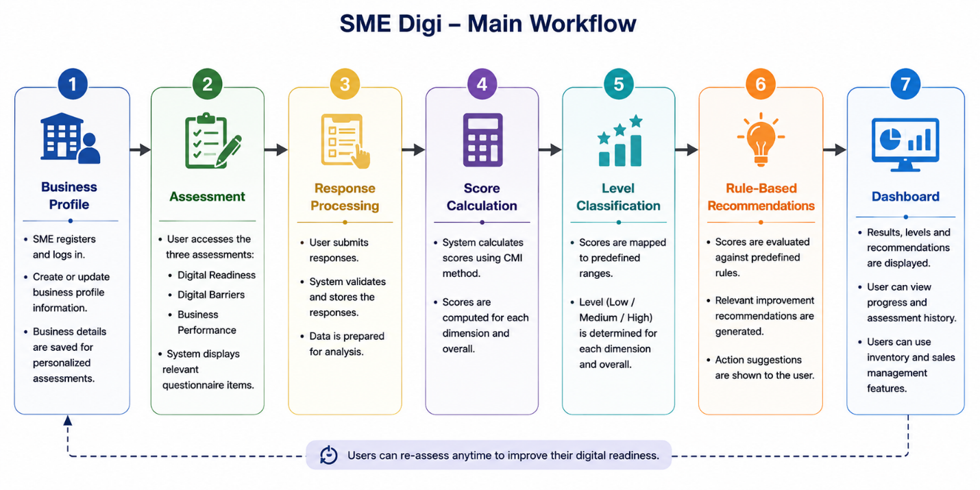
2.6 Reflection – Research Gap

The reviewed research shows that digital transformation among SMEs is influenced by several factors, including technology, organizational conditions, financial capabilities, workforce skills, and the external environment [3], [4], [6]. The TOE Framework [10], SME IT Adoption Model [11], and Diffusion of Innovations Theory [13] provide useful theoretical foundations for understanding these factors. Studies focusing on Sri Lankan SMEs have also identified several specific challenges that make successful digital technology adoption difficult [6], [7], [9].
Previous studies have shown the value of assessing SME digital readiness and supporting decision-making [15], [16]. However, much of the existing research focuses on identifying and analysing the factors affecting digital adoption rather than developing a practical tool that SME owners and managers can use to understand their current situation and identify areas for improvement.
Another identified gap is the consideration of different business types. SMEs operating in different sectors may use digital technologies differently and may have different requirements for digital adoption. Therefore, an assessment that considers the business type and provides relevant questions can produce more meaningful results. In addition, providing only an assessment score may not offer sufficient practical guidance. A rule-based recommendation approach can help translate assessment results into understandable suggestions for improvement [21].
Therefore, the main research gap identified is the lack of a practical and context-sensitive digital decision-support platform for Sri Lankan SMEs that can assess Digital Readiness, Digital Barriers, and Business Performance, while considering differences in business type. The platform should also provide meaningful assessment scores and recommendations for improvement. The proposed SME Digi platform is designed to address this gap and provides lightweight inventory and sales-management functions as supporting business tools.

CHAPTER 03
RESEARCH METHODOLOGY
This chapter outlines the methodology used to study the digital readiness of Small and Medium Enterprises (SMEs) in the island of Sri Lanka and to design and develop the proposed SME Digi platform. The chapter describes the research paradigm, research approach, research strategy, fact collection mechanism, research methodology execution workflow, project management methodology, project timeline and ethics.
The research combines an empirical quantitative investigation of SMEs using a structured questionnaire with the design and development of a web-based decision-support artefact. The empirical component collects evidence on the characteristics of digital readiness, barriers to digital adoption and the performance of the business while the system development component transforms the identified requirements and findings in the SME Digi platform. These principles of Design Science Research (DSR) are thus embedded in the methodological workflow as it is a development and evaluation research of an information-system artefact aimed at addressing a practical problem that has been identified [23].

3.1 Research Paradigm
Pragmatism can be considered suitable for this research since it enables research techniques to be chosen based on how well they meet the needs of the research problem [18]. In this case, quantitative data collected through questionnaires will be used to explore SME Digital Readiness, Digital Barriers and Business Performance and then used to develop an effective web artefact.
This research is pragmatist because it is required to (a) measure the digital readiness and barrier level of SMEs using measurable instruments on Likert scales and (b) design and test out a web-based system which is practical. This combination is obviously a combination of objective measurement and subjective evaluation and thus pragmatism is the most suitable philosophy [18].

3.2 Research Approach

This study adopts a deductive research approach, as it is guided by established theories and seeks to test their applicability within the context of digital transformation among Small and Medium Enterprises (SMEs) in Sri Lanka. The deductive approach begins with existing theoretical frameworks, formulates research objectives based on these theories, and collects empirical data to validate the proposed relationships [18], [20].
The research is primarily based on the Technology–Organization–Environment (TOE) Framework proposed by Tornatzky and Fleischer [10] and the SME IT Adoption Model developed by Thong [11]. These theories provide the conceptual foundation for investigating the technological, organizational, and environmental factors that influence SMEs' digital readiness, digital barriers, and business performance.
To examine these factors, quantitative data are collected through a structured questionnaire distributed to SME owners and managers across Sri Lanka. The questionnaire consists of closed-ended questions measured using a five-point Likert scale. The collected data are analyzed using descriptive statistics and Composite Mean Index (CMI) calculations. Reliability analysis, correlation analysis, and regression analysis are applied where appropriate to the research constructs and final dataset
. The research findings are subsequently utilized to develop a web-based decision support platform capable of assessing digital readiness, identifying digital barriers, and generating rule-based recommendations to support SMEs in their digital transformation journey.

The deductive research approach is considered appropriate because this study evaluates existing theoretical concepts using empirical evidence rather than generating a new theory. According to Creswell and Creswell [18], deductive reasoning is widely employed in quantitative research where hypotheses or research constructs are derived from established theories and validated through statistical analysis. Similarly, Saunders et al. [20] state that deductive reasoning is particularly suitable for business and information systems research that seeks to examine theoretical relationships using structured quantitative data.
3.3 Research Strategy
A quantitative survey strategy combined with Design Science Research (DSR) is adopted for this study.

The quantitative survey strategy is used for the empirical component of the research. Survey research enables standardized information to be collected from multiple respondents and supports quantitative analysis of variables and relationships [18], [20]. The target respondents are owners and managers of SMEs operating in different business sectors in Sri Lanka.

A structured questionnaire is used as the primary survey instrument. The questionnaire measures three principal research areas: Digital Readiness, Digital Barriers, and Business Performance. Digital Readiness includes Infrastructure Readiness, Financial Readiness, Digital Skills and Workforce, Strategic Readiness, and Cybersecurity Preparedness. Digital Barriers include Financial, Technical, Organizational, and Environmental barriers. Business Performance evaluates the relevant performance indicators included within the research instrument.

The quantitative responses are analysed using descriptive statistical techniques and the Composite Mean Index (CMI) to identify the relative level of each assessment dimension. Reliability analysis using Cronbach's Alpha can be used to examine the internal consistency of multi-item constructs. Correlation and regression analyses are conducted where appropriate to the final dataset and research questions to examine relationships among the major research variables.

The second component of the strategy involves Design Science Research. Design Science is appropriate in information-systems research where an artefact is created to address an identified organizational problem [24]. In this research, SME Digi represents the research artefact. The empirical findings and theoretical foundations are translated into system requirements, assessment dimensions, scoring mechanisms, rule-based recommendations, and supporting business functions.

Therefore, the survey strategy provides empirical evidence about the research problem, while DSR provides a structured approach for translating the identified problem and requirements into a technological solution.

3.4 Fact Collection Mechanisms
The primary fact collection mechanism used in this research is a structured questionnaire survey. The questionnaire was selected because the study requires standardized and measurable information from SME owners and managers concerning their current digital practices, readiness, barriers to digital adoption, and business performance. Structured questionnaires are appropriate for quantitative studies because responses can be systematically coded and analysed statistically [18], [20].

The questionnaire consists of organizational information and three principal assessment components. The Digital Readiness Assessment evaluates five dimensions: Infrastructure Readiness, Financial Readiness, Digital Skills and Workforce, Strategic Readiness, and Cybersecurity Preparedness. The Digital Barriers Assessment evaluates Financial, Technical, Organizational, and Environmental barriers. The Business Performance Assessment measures the business-performance indicators included in the research instrument.

Most assessment statements are measured using a five-point Likert scale, allowing respondents to indicate their level of agreement with each statement. General questions are also included to identify characteristics such as business type and current use of digital technologies.

The study targets approximately 80 SME respondents. Purposive sampling is used to select respondents relevant to the research problem, particularly SME owners and managers capable of providing information regarding their organizations' business operations and digital practices. The complete questionnaire used for data collection is included in Appendix A.

3.4.1 Questionnaire Response Analysis

The questionnaire responses are analyzed quantitatively. Initially, the collected responses are reviewed and prepared for analysis. Demographic and organizational characteristics are summarized using frequencies and percentages to describe the participating SMEs according to variables such as business type, business characteristics, and current use of digital technologies.

The Likert-scale responses are subsequently analyzed using descriptive statistics and Composite Mean Index (CMI) calculations. CMI values are calculated for the individual dimensions of Digital Readiness, Digital Barriers, and Business Performance. These results enable comparison among dimensions and identification of areas in which SMEs demonstrate comparatively stronger or weaker conditions.

For Digital Readiness, CMI calculations are performed for Infrastructure Readiness, Financial Readiness, Digital Skills and Workforce, Strategic Readiness, and Cybersecurity Preparedness. For Digital Barriers, calculations are performed for Financial, Technical, Organizational, and Environmental barriers. A higher barrier score represents a greater perceived barrier and therefore requires different interpretation from a high readiness score.

Where multiple questionnaire items measure the same construct, Cronbach's Alpha may be used to examine internal consistency. Correlation and regression analyses are applied where appropriate to the final dataset and research objectives.

The detailed quantitative results are presented and interpreted in Chapter 4, while supporting questionnaire material and supplementary statistical outputs can be provided in the appendices.

3.5 Research Methodology Execution Workflow

The research methodology execution workflow was structured using principles of Design Science Research Methodology (DSRM). Design Science Research is appropriate because the study moves beyond identifying and analyzing an organizational problem and develops a technological artefact intended to address that problem. Peffers et al. describe DSRM through the stages of problem identification and motivation, definition of solution objectives, design and development, demonstration, evaluation, and communication [23].

The workflow was adapted to the requirements of the SME Digi research as follows.

Stage | Application within SME Digi Research
Problem Identification | Identify challenges faced by Sri Lankan SMEs in adopting and effectively using digital technologies through literature review and preliminary investigation.
Relevance Justification | Establish the economic importance of SMEs and demonstrate the practical need for assessing digital readiness, barriers, and business performance.
Comparative Analysis and Gap Justification | Review existing digital-transformation, technology-adoption, readiness-assessment, and decision-support studies to identify limitations and the research gap addressed by SME Digi.
Define and Finalize Objectives | Formulate the research aim, questions, and objectives and determine the required assessment dimensions and expected capabilities of the proposed solution.
Design / Development / Data Management and Handling | Collect questionnaire data, analyse empirical results, define system requirements, design the database and system architecture, and develop SME Digi as the research artefact.
Evaluation and Communication | Test the implemented system, evaluate whether the required functions operate correctly, discuss the research findings and system contribution, and communicate the study through the thesis and research paper.

3.5.1 Problem Identification

The study started with an identification of the problems of SMEs in the adoption of digital technologies. Existing literature suggests that limited technological resources, financial constraints, workforce capabilities and readiness, cybersecurity concerns and external environmental conditions [3] [6] [9] can all affect the digital transformation of SMEs.

Problem identification also indicated that the SME owners/managers might understand the need for digitalization but might not have an easy-to-use tool to assess the readiness of their business and the priority areas that should be addressed. This was the first motivation for the exploration of SME digital readiness and later on for the development of SME Digi.

3.5.2 Relevance Justification

To ensure the relevance of the research, the significance of SMEs to the Sri Lankan economy and the increasing role of digital technologies in business operations were taken into consideration [1]. Digital transformation can impact on the efficiency, competitiveness, customer interaction and decision-making processes within the organization, but for SMEs, resources and capabilities can be different from larger organizations [5], [6].

The study is therefore relevant both from an academic and practical point of view as it deals with the understanding of the conditions of digital transformation of SMEs and offers an easily accessible instrument for evaluating and interpreting these conditions.
3.5.3 Comparative Analysis and Gap Justification

The previous literature on the TOE, DOI, SME IT adoption, digital transformation and digital readiness was comparatively analyzed to conclude how the past research have dealt with the technology adoption in SMEs [2], [10], [11], [13], [17].
The digital-readiness indicators have been shown in previous studies to be converted into decision-support mechanisms [15] and [16]. The literature review, however, revealed a need for a context-specific platform that enables the integration of readiness, digital barriers, business performance, business type specific assessment questions, scoring interpretations and recommendations for improvement for Sri Lankan SMEs.
The gap identified justified the development of the proposed research artefact, SME Digi.

3.5.4 Define and Finalize Objectives
Once the research problem and gap was identified, the research goal was finalized. The goals were to define digital-transformation challenges, to assess digital readiness of SMEs, to explore barriers and business performance, and to create a rule-based system to provide individual improvement guidance.
The concepts and empirical needs were then mapped to the main assessment areas: Digital Readiness, Digital Barriers and Business Performance. These goals were used as a base for the development of questionnaires and finally the requirements of the system.

3.5.5 Design, Development, Data Management and Handling
Empirical data handling and software development occurred during the design and development stage. The answers to the questions in the questionnaire were prepared for quantitative analysis and examined the constructs of the research. The results of the findings were then translated to functional and non-functional requirements for SME Digi as per the identified research gap.
It is a web-based system with a Reactjs & Vite client front-end, PHP app/API and MySQL database. The system supports SME registration and authentication, assessment questions based on the type of business, Digital Readiness, Digital Barriers and Business Performance assessment questions, CMI based scoring, rule based recommendations, visualization in the dashboard, inventory management, sales management, and limited administrative monitoring.
The recommendation component is based on a transparent “rule-based” approach, with a set of conditions mapped to a set of recommendations. Rule-based decision-support mechanisms are structured approaches to make system decisions and recommendations based on defined conditions [21].

3.5.6 Evaluation and Communication

The developed SME Digi artefact is assessed to see if the requirements and functions were met in the evaluation stage. Evaluation is a critical component in Design Science Research as the artefact has to be useful and effective [23].
Testing of the system includes the functional testing of all critical functions such as authentication, retrieving assessment questions, answering questions, scoring answers, generating recommendations, showing dashboard, managing inventory, conducting sales, and monitoring administration.
Lastly, the final thesis and corresponding research paper transmit the research question, method, experimental results, system designing, system implementation, system evaluation, limitations and recommendations.

3.6 Project Management Methodology

It was decided to use the Scrum Agile methodology to handle the development tasks of the SME Digi platform. Scrum embraces iterative and incremental software development methodology by implementing short development cycles, and the functionality is gradually implemented, reviewed and enhanced [19].

Since the project involved academic research and software development, Scrum was deemed appropriate for SME Digi. Theoretical results, the design and analysis of questionnaires, feedback from supervisors, system testing and refining the research framework all had an impact on the system requirements. Thus some requirements may, therefore, change during the development of the project, not necessarily from the outset.

It also has several interconnected modules such as registration and authentication, three assessment modules, business-type-specific questions, CMI-based score calculation, rule-based recommendations, dashboard functions, inventory management, sales management and administrative monitoring. These components were broken up into manageable development cycles and gradually integrated with the use of an iterative development methodology.

The reasons for this were that the requirements were not well defined, so a Waterfall approach would have been more suitable if they were, and that the requirements were expected to change frequently during the iterative development of Scrum. SME Digi's ongoing research and prototype needs necessitated increased flexibility. Although it was very clear that PRINCE2 would give the project governance and project-control processes that would be very thorough, it was felt that this was too extensive for an individual undergraduate research-development project. Kanban could be an effective way of tracking the tasks continuously, however, it was decided to select Scrum as it had clear iterations and review points that would be best suited to creating the development of the individual SME Digi modules.

Scrum was chosen as it is iterative and incremental, which matched the research problem, the changing nature of the proposed artefact, and a progressive approach to designing, building, testing and improving the system.

3.6.1 Project Timeline

Month | Phase | Key Deliverables
Month 1 | Problem Identification & Literature Review | Research proposal, Chapter 1 draft, Chapter 2 draft
Month 2 | Methodology & Questionnaire Design | Chapter 3, finalized questionnaire instrument
Month 3 | Data Collection & Sprint 1–2 Development | Survey responses (n≥80), Registration & Assessment modules
Month 4 | Sprint 3–4 Development | Recommendation engine, Dashboard, Inventory module
Month 5 | System Testing & UAT | Test reports, UAT feedback, system refinements
Month 6 | Data Analysis & Thesis Completion | Chapters 4–6, final submission

3.6.2 Ethical Considerations

The research involved the collection of questionnaire responses from SME owners and managers. Participation in the questionnaire was voluntary, and the collected information was used only for academic research purposes. Respondents were informed about the purpose of the study before completing the questionnaire.
The questionnaire did not require respondents to provide unnecessary personally identifiable information. The collected responses were treated confidentially and were analyzed and presented in an aggregated manner. The researcher also ensured that the collected data and research findings were reported accurately without altering or fabricating responses.

3.7 Chapter Summary

This chapter presented the methodological framework adopted for investigating SME digital transformation and developing the proposed SME Digi platform. A pragmatist research paradigm was selected because the research focuses on addressing a practical SME problem through empirical investigation and technological development. A primarily deductive approach was adopted because established technology-adoption theories and previous research informed the constructs examined through the study.
A quantitative survey strategy was used for the empirical investigation, with a structured questionnaire serving as the primary fact collection mechanism. The questionnaire measures Digital Readiness, Digital Barriers, and Business Performance, while quantitative analysis is used to interpret the collected responses.
The development component follows principles of Design Science Research, through which the identified problem and empirical requirements are translated into SME Digi as the research artefact. The research workflow includes problem identification, relevance justification, comparative analysis and gap identification, definition of objectives, design and development, and evaluation and communication. Scrum was selected as the project management methodology because its iterative and incremental characteristics were suitable for the evolving requirements of the research and software-development process.
The following chapter presents the analysis of the collected questionnaire data and discusses the major findings in relation to the research objectives and the development of SME Digi.

- System Requirement Specification.
  - Existing System Analysis.

Most SMEs in Sri Lanka are currently relying on different digital solutions and manual methods, including spreadsheets, paper records, social media, and simple business tools, to support their day-to-day operations. However, these approaches are often fragmented and do not provide a systematic way for SME owners to assess digital readiness, digital barriers, and business performance within a single integrated system. Digital transformation in SMEs involves several interconnected technological and organizational factors, which highlights the importance of considering digital adoption through an integrated approach rather than through isolated technologies [24].
Additionally, SME owners may struggle to identify which areas of digital adoption require improvement and what actions should be taken. Therefore, there is a need for an integrated assessment and decision-support system that can evaluate important digital factors, identify areas requiring attention, and provide appropriate recommendations for improvement.

  - Proposed System.

The SME Digi project is a web-based Digital Readiness Assessment and SME Support System, which has been developed to support Sri Lankan SMEs. Three primary assessments are offered for: Digital Readiness, Digital Barriers, and Business Performance. Assessment scores are calculated, the results are classified based on predefined levels and recommendations are made based on the identified conditions of the SME, using rule-based logic.

The system also offers an SME dashboard, assessment history, basic inventory and sales management and an independent administrative interface to track registered SMEs and assessment results. Assessment questions include common and business-type-specific questions, allowing the assessment process to be more relevant to different types of SMEs.
4.3 Stakeholder Analysis
Stakeholder analysis is a crucial and vital aspect of requirements engineering; stakeholders are defined as individuals or organizations with an interest in a system and its expected properties [25]. Knowing who the stakeholders are helps to determine the different system needs and requirements. Three key stakeholders were identified for SME Digi: SME Owner/Manager, System Administrator, and Researcher/System Developer.

Stakeholder | Role | Main Needs/Interests | Interaction with SME Digi
SME Owner/Manager | Primary User | Assess digital readiness, identify digital barriers, understand business performance and obtain recommendations | Registers/logs in, completes assessments, views results and recommendations, accesses history, and manages inventory and sales
System Administrator | Administrative User | Monitor registered SMEs and assessment activities | Accesses the admin dashboard, views SME users and reviews assessment results
Researcher/System Developer | Development Stakeholder | Ensure that research requirements are correctly implemented and the system operates as expected | Designs and develops the system, implements assessment and recommendation logic, maintains the system and performs testing

SME Owner/Manager
The SME Owner/Manager is the main stakeholder of SME Digi. The system allows SME users to get a score on Digital Readiness, Digital Barriers, and Business Performance, based on their answers. To evaluate the digital readiness of SMEs, digital readiness assessment and decision support based on a digital dashboard have been used previously [15]. In SME Digi, users can take assessments, check their scores and readiness level, get recommendations based on the rules and check their past assessment scores. The system also features basic inventory and sales functions, where SMEs can enter their basic operational data and get relevant data displayed in the dashboard.

System Administrator
The System Administrator will perform the administrative tasks of SME Digi. The administrator will be able to access the administrative dashboard and view the list of SMEs registered, monitor SME categories, and review the assessment results. Separation of administrative and SME-user access ensures that the two user roles only interact with the functions that are relevant to their roles.

Researcher/System Developer
The Researcher/System Developer is responsible for realizing the identified research and system requirements within the implemented SME Digi platform. The developer participates in requirements analysis, system design, development, testing, and evaluation. As part of this research, the developer must decide the assessment structure, the algorithms for score calculation and classification, the algorithm for the recommendation mechanism, the integration of the front end, back end and database and the system testing.

4.4 Questionnaire Analysis and Requirement Identification

The primary purpose of questionnaire analysis is to determine the requirements of the user. The main goal of questionnaire analysis is to identify the requirements of the user. Data was gathered from Small and Medium Enterprises using a structured questionnaire on the following areas: Digital practices, Digital readiness, Barriers to digital adoption, Business performance. Data collected was analyzed in IBM SPSS Statistics. The collected data was analyzed using frequency analysis, descriptive statistics and reliability analysis. The results were then presented to aid in the identification of the requirements of the proposed SME Digi system.

4.4.1 Mapping Questionnaire Areas to Research Objectives
The questionnaire was segmented into different areas to collect the information pertinent to the objective of research and the proposed system

Questionnaire Area | Purpose
SME Profile | Identify the characteristics of participating SMEs
Digital Technology Usage | Identify the current usage of digital tools
Digital Readiness | Assess infrastructure, financial, workforce, strategic, and cybersecurity readiness
Digital Barriers | Identify challenges affecting digital adoption
Business Performance | Examine perceived business improvements related to digital adoption
Support Requirements | Identify the types of digital tools and support required by SMEs

This survey therefore helped in the process of carrying out the research as well as establishing practical needs for SME Digi.
4.4.2 Respondent Profile
Frequencies and descriptive statistics were used to analyze the respondent profile. The primary attributes which were considered are industry type, years in operation, number of employees, current digital-tool usage, and frequency of usage.

Industry Type
The respondents represented several different business sectors.
Industry Type | Frequency | Percentage
Manufacturing | 33 | 31.4%
Services | 25 | 23.8%
Industry | 17 | 16.2%
Agriculture | 12 | 11.4%
Retail | 11 | 10.5%
Other categories | 7 | 6.7%
Total | 105 | 100.0%

Manufacturing was the highest group of respondents with 31.4%, while services had 23.8%. It means that the respondents belonged to various types of small and medium-sized enterprises.

Years in Operation
Years in Operation | Frequency | Percentage
Less than 1 year | 3 | 2.9%
1–3 years | 14 | 13.3%
3–5 years | 22 | 21.0%
5+ years | 66 | 62.9%
Total | 105 | 100.0%
Most respondents 62.9% were from companies with 6+ years of operation. Another 21% per cent had been in operation for 3-5 years. This means that most of the participants were from businesses that had mature experience and were well-established.

Current Use of Digital Tools
Response | Frequency | Percentage
Yes | 71 | 67.6%
No | 34 | 32.4%
Total | 105 | 100.0%

The findings show that 67.6% of respondents are currently using digital tools in their business and 32.4% don't currently use digital tools. This discovery indicates that although most respondents make use of digital technology, there is a significant number of SMEs that do not use digital tools regularly.

Frequency of Digital Tool Usage
Among respondents who reported frequency of digital-tool usage, daily and weekly usage represented the main categories.
The Google Forms summary showed 70 responses to this question:
Frequency | Percentage
Daily | 51.4%
Weekly | 37.1%
Monthly | 8.6%
Rarely | 2.9%

More than half of the respondents who answered this question reported using digital tools daily, while more than one-third used them weekly. Many SMEs already use digital technologies in their day-to-day operations, which suggests that they are already doing so on a regular basis.

Number of Employees
Employee information was available for 104 respondents.
Statistic | Result
Minimum | 1
Maximum | 270
Mean | 44.89
Standard Deviation | 56.90
The average of employees was 44.89 with a fairly large standard deviation, suggesting that there is significant variation in the size of participating businesses.

4.4.3 Reliability Analysis
The internal consistency of the questionnaire items under Digital Readiness, Digital Barriers, and Business Performance were assessed through reliability analysis using Cronbach's Alpha.

Construct | Number of Items | Cronbach's Alpha
Digital Readiness | 5 | 0.407
Digital Barriers | 10 | 0.379
Business Performance | 5 | 0.246

The values of Cronbach's alpha that were obtained on the reliability analysis were relatively low for all three groups. Digital Readiness generated an alpha of 0.407; Digital Barriers, 0.379; and Business Performance, 0.246. These values show that there is a limited internal consistency of these items composite scale. Digital Readiness, for instance, encompasses separate areas of readiness, such as infrastructure, financial ability, the skill sets of the workforce, strategic planning, and cybersecurity. The analysis of the data therefore will be restricted to the individual dimensions and the individual questionnaire items and will be based on descriptive statistics. The low reliability values are seen as a limitation to the study

4.4.4 Digital Readiness Analysis
Digital Readiness was measured across five areas:
- Infrastructure Readiness
- Financial Readiness
- Workforce Readiness
- Strategic Readiness
- Cybersecurity Readiness

The following classification was used for interpretation:
Mean Range | Level
1.00–2.60 | Low
2.61–3.40 | Moderate
3.41–5.00 | High

Digital Readiness Results
Digital Readiness Dimension | N | Mean | Std. Deviation | Level
Infrastructure Readiness | 70 | 2.61 | 0.906 | Moderate
Financial Readiness | 70 | 3.21 | 0.961 | Moderate
Workforce Readiness | 70 | 3.11 | 0.971 | Moderate
Strategic Readiness | 71 | 3.10 | 1.002 | Moderate
Cybersecurity Readiness | 71 | 2.79 | 1.182 | Moderate
All five Digital Readiness dimensions were in the moderate end of the spectrum. The mean scores for each of the three components of financial readiness (M=3.21), workforce readiness (M=3.11), and strategic readiness (M=3.10) were largest for each of the components. The mean for Cybersecurity Readiness was 2.79 and Infrastructure Readiness had the lowest mean of 2.61. All dimension scores were considered at the moderate level, but the scores for Infrastructure and Cybersecurity Readiness were lower than the other readiness dimension scores. The results suggest that SMEs need more support, especially regarding technology infrastructure and cyber security readiness.

4.4.5 Digital Barriers Analysis

Used the following scale:
1 = Not a Challenge
2 = Minor Challenge
3 = Moderate Challenge
4 = Serious Challenge
5 = Very Serious Challenge

The higher the mean value the more severe the digital-adoption barriers.
Digital Barrier | N | Mean | Std. Deviation
High cost of digital tools | 70 | 3.67 | 0.959
Lack of digital skills among employees | 71 | 3.24 | 0.886
Poor internet connectivity | 71 | 2.89 | 1.141
Lack of awareness about digital tools | 70 | 3.39 | 1.094
Cybersecurity concerns | 71 | 4.13 | 0.970
Resistance to change from staff | 71 | 3.32 | 1.011
Lack of government support | 71 | 3.41 | 0.979
Lack of clear digital strategy | 71 | 3.32 | 0.922
Difficulty integrating systems | 70 | 3.43 | 0.894
Limited access to financial support | 67 | 3.27 | 0.947

Cybersecurity Concerns had the highest mean score (M = 4.13), indicating that this was seen as a very serious digital-adoption concern. The second highest mean (M = 3.67) was the mean for the High Cost of Digital Tools. Difficulty Integrating Systems (M = 3.43) and Lack of Government Support (M = 3.41) were also relatively high. Poor Internet Connectivity had the lowest mean (M = 2.89) but was still considered at a moderate level of concern. The results indicate that barriers are of varying types and intensities for different SMEs. This is in support of the need to identify the weaknesses and give recommendations based on the individual SME's condition rather than giving the same recommendation to all SMEs.

4.4.6 Business Performance Analysis
Respondents were asked to indicate the extent to which digital adoption had affected several areas of business performance.

Business Performance Indicator | N | Mean | Std. Deviation
Improved Revenue | 70 | 3.56 | 0.792
Improved Cost Efficiency | 70 | 3.30 | 0.857
Improved Productivity | 70 | 3.87 | 0.721
Improved Customer Satisfaction | 70 | 3.63 | 1.024
Improved Operational Efficiency | 70 | 3.59 | 0.876

The highest mean was for Improved Productivity (M = 3.87). These were succeeded by Improved Customer Satisfaction (M = 3.63), Improved Operational Efficiency (M = 3.59) and Improved Revenue (M = 3.56). The mean (M = 3.30) was lowest for Improved Cost Efficiency. Results show a mainly positive view of the impact of digital adoption on various dimensions of business performance, especially productivity. These results, however, are derived from items with low reliability that are not aggregated into a composite overall business-performance item.

4.4.7 Implications for SME Digi System Requirements
The results of the questionnaire were utilized to support the identification of the functional needs and decision-support functions of SME Digi.

Survey Finding | Implication for SME Digi
Digital readiness varies across different dimensions | Assess Infrastructure, Finance, Workforce, Strategy, and Cybersecurity separately
Infrastructure readiness was comparatively low | Include infrastructure-related recommendations
Cybersecurity readiness was comparatively low | Provide cybersecurity preparedness recommendations
Cybersecurity concerns recorded the highest barrier mean | Include cybersecurity-related guidance in the recommendation mechanism
High cost of digital tools was also a major barrier | Include affordable and practical digital adoption recommendations
SMEs experience different barriers | Generate customized recommendations based on assessment results
Some SMEs do not currently use digital tools | Keep the system simple and understandable for less digitally experienced users
Digital adoption showed positive perceived effects on productivity and other performance areas | Encourage improvement of digital capabilities through targeted recommendations

The survey results are aligned with the three main assessment areas currently covered under SME Digi: Digital Readiness, Digital Barriers and Business Performance. The proposed system already has these assessment functions and computing scores and classification levels prior to the application of pre-defined recommendation rules. The results also validate dimension-based assessment.

SME Digi does not offer a one-size-fits-all solution, but rather focuses on those areas where an SME needs more attention and offers suggestions for improvement based on conditions defined by rules. Hence the questionnaire analysis serves as a bridge between the results of the research and the system requirements. It offers evidence that SMEs differ in their level of readiness, barriers, perceived business outcomes and supports the need for an assessment-based decision-support system.

4.4.8 Summary of Survey Analysis
The questionnaire analysis gave an understanding of the current situation of digitality of the included SMEs. The results revealed that most of the participants are already using digital tools and a significant portion are not using any. The mean scores were at a moderate level for all five dimensions of Digital Readiness, with Infrastructure and Cybersecurity Readiness showing relatively low scores. The two top digital barriers were Cybersecurity Concerns and High Cost of Digital Tools. In the Business Performance results, respondents rated the positive impact of digital adoption to be the greatest on productivity

. The reliability analysis showed that the internal consistency in the grouped constructs was low but the descriptive results of the items gave information about the various digital conditions of SMEs. The findings were primarily used for the individual assessment dimensions and requirement identification of the SME Digi platform.

  - User Requirements

The user requirements represent the main expectations of the two primary users of SME Digi. Further details of system functions and quality requirements are specified under the Functional and Non-Functional Requirements.

User | Main Requirements
SME Owner/Manager | Complete assessments, view scores and classifications, receive recommendations, view assessment history and dashboard information, and manage basic inventory and sales records.
System Administrator | Access the administrative dashboard, view registered SMEs, and monitor SME assessment results and activities.

  - Functional Requirements

The functional requirements represent the functions and behaviors that a software system should provide, whereas, the non-functional requirements refer to the quality characteristics and constraints of a software system, such as usability, performance, security, reliability, maintainability, and compatibility [26].

The research goals, the research results regarding the digital transformation of SMEs and the functions required by the decision-support platform were used as the basis for identifying the requirements of the SME Digi platform. The functional requirements are grouped based on the two main actors of the system: SME User, and Administrator. The SME User carries out the bulk of the assessment and business-support activities, whereas the Administrator monitors the platform and manages the SME-users.

The requirements are split into the two primary roles of the proposed system.

A. SME User Functional Requirements
- SME users can register, log in, log out, and update basic SME information (e.g., business type).
- SME users can complete Digital Readiness, Digital Barriers, and Business Performance assessments.
- Assessment questions shown depend on the SME's registered business type.
- System calculates assessment scores using the Composite Mean Index (CMI) and assigns results based on defined levels.
- System gives rule-based recommendations from assessment results and predefined decision rules.
- SME Dashboard shows the latest assessment results and relevant business info.
- SME users can view their past assessment history.
- SME users can create, view, update, and delete inventory records; system flags low-stock items.
- SME users can create, view, edit, and delete sales transactions (sale date, payment method, product name, quantity, unit price).
- System computes and displays sales data (sale amount, overall sales summary, etc.).

B. Administrator Functional Requirements
- Admins can securely register, log in, and log out of the admin interface.
- Admin Dashboard gives an overview of registered SMEs and assessment activity.
- Admins can view and track basic info of registered SME users.
- Admins can view SME assessment results for Digital Readiness, Digital Barriers, and Business Performance.
- Admin and SME user functions are kept separate in the system.

4.7 Non-Functional Requirements
Non-Functional Requirement | Description
Usability | Simple, clear interface suitable for SME owners/managers regardless of technical skill level.
Performance | Assessment, recommendation, dashboard, inventory, and sales operations run within reasonable response times.
Security | User authentication, input validation, secure password handling, and separation of SME User and Admin access.
Reliability and Accuracy | Data is stored/retrieved reliably; assessment scoring, classification, recommendations, and calculations follow the defined system logic accurately.
Maintainability | Frontend, backend, business logic, and database are structured to support easy maintenance and future changes.
Compatibility | Works on commonly available modern web browsers.

  - Use Case analysis

Use Case analysis was carried out to find the main interactions between the users and SME Digi. There are two main actors in the system: SME User, System Administrator. The main functions associated with digital assessment, rule-based recommendations and administrative monitoring are analyzed.

Use Case 1 – Complete Digital Assessment

Field | Description
Use Case Name | Complete Digital Assessment
Primary Actor | SME User
Precondition | SME users are registered and logged in.
Trigger | User selects Digital Readiness, Digital Barriers, or Business Performance Assessment.
Main Flow | 1.System retrieves relevant questions based on assessment type and business type.  2. User answers the questions.  3. User submits answers.  4. System validates responses.  5. System calculates assessment scores.  6. System classifies the result.  7. Results are stored and displayed.
Alternative Flow | If required questions are incomplete, the system requests the user to complete them.
Postcondition | Assessment responses and calculated results are stored.

Use Case 2 – View Recommendations

Field | Description
Use Case Name | View Recommendations
Primary Actor | SME User
Precondition | SME users have completed the relevant assessment.
Trigger | User opens the Recommendations section.
Main Flow | 1. System retrieves assessment results.  2.Results are compared with predefined recommendation rules.  3.Relevant recommendations are identified.  4. Recommendations are displayed.
Postcondition | SME users receive improvement recommendations based on assessment results.

Use Case Specification 3 – Monitor Assessment Results

Field | Description
Use Case Name | Monitor Assessment Results
Primary Actor | Administrator
Precondition | Administrator is logged in.
Trigger | Administrator opens Assessment Results.
Main Flow | 1. System retrieves SME assessment information.  2. Assessment results are displayed.  3. Administrator reviews SME assessment activities.
Postcondition | Administrators can monitor recorded SME assessment results.

  - User Stories

User stories were defined to represent the main system requirements from the perspective of the primary users of SME Digi. The main users considered are the SME Owner/Manager and System Administrator.

ID | User | User Story
US01 | SME Owner/Manager | As an SME owner/manager, I want to complete Digital Readiness, Digital Barriers, and Business Performance assessments so that I can understand the current digital condition of my business.
US02 | SME Owner/Manager | As an SME owner/manager, I want assessment questions relevant to my business type so that the assessment is more appropriate to my business context.
US03 | SME Owner/Manager | As an SME owner/manager, I want to view my assessment scores and classification levels so that I can identify areas that require improvement.
US04 | SME Owner/Manager | As an SME owner/manager, I want to receive rule-based recommendations based on my assessment results so that I can identify suitable actions for digital improvement.
US05 | SME Owner/Manager | As an SME owner/manager, I want to view previous assessment results so that I can review my assessment history.
US06 | SME Owner/Manager | As an SME owner/manager, I want to maintain inventory records and identify low-stock items so that I can monitor basic inventory information.
US07 | SME Owner/Manager | As an SME owner/manager, I want to record and review sales transactions so that I can monitor basic sales information.
US08 | System Administrator | As a system administrator, I want to view registered SMEs and their assessment results so that I can monitor SME Digi activities.

4.10 System Constraints
The SME Digi system has been designed as an academic research prototype and thus has several practical and technical limitations. Current implementation is deployed and tested on a local development environment (XAMPP), not on a public production server. The system is thus primarily meant to visualize and test the suggested assessment and decision-support functions.

This is a rule-based recommendation mechanism which relies on predefined assessment classifications and the rules used to make a recommendation. No Artificial Intelligence/Machine Learning is used to make a prediction of SME performance and recommendations are not automatically generated by the system. The accuracy and completeness of information given by SME users also affects the quality of assessment results. Responses to the questions on the assessments are self-reported and cannot be automatically determined by the system whether they reflect the true situation of the business.

The inventory and sales are carried out as basic business supporting functions. In the current implementation they work independently, a sale does not automatically update finished product or raw material inventory. The current system will not handle more advanced integration with inventory. It also needs to have a modern web browser and an active application and database environment to use the functions of the system.

4.11 Feasibility Analysis

Technical Feasibility
Feasible — built using common, accessible tech (React.js, Vite, JSX for frontend; PHP backend; MySQL/MariaDB database; XAMPP for local hosting). Enough to manage logins, evaluations, scoring, recommendations, dashboards, inventory, sales and admin.

Operational Feasibility
Feasible — for owners/managers of SMEs with any level of technical sophistication. Easy navigation and hassle-free assessment process (pick assessment, answer questions, submit, view results). Easy to access Dashboard, recommendations, history, inventory and sales.

Economic Feasibility
Feasible – Prototype not expensive as it does not require proprietary software or infrastructure; built and tested by the researcher on their own computer with free/local software, keeping prototype costs low.

Schedule Feasibility
Feasible – scope was limited to core features (assessments, scoring/classification, recommendations, dashboards, history, basic inventory/sales, admin monitoring). Some of the more advanced functions such as AI-driven recommendations and automatic syncing of sales and inventory were omitted and mentioned as future work.

CHAPTER 05

5.1 System architecture
The SME Digi system is based on a layered Web-based architecture which separates the user interface, application processing, business logic, and data management functions. Developed with React.js, Vite, JSX and CSS for the Presentation Layer, it provides the interfaces with which SME users and administrators communicate with the system. The Application/API Layer, which is built with PHP, receives requests from the frontend, authenticates with the user, validates, processes the system and communicates with the Database.

The Business Logic Layer is the primary layer for decision-support services of SME Digi. It handles Digital Readiness, Digital Barriers, and Business Performance assessments, calculates the relevant dimension and overall CMI scores, classifies the results according to predefined levels, and applies rule-based logic to generate recommendations. It also handles dashboard, inventory, sales and administrative functions. SMEs and administrators’ information, assessment questions and answers, assessment scores, recommendation rules, inventory records and sales records are stored in the Data Layer using MySQL. A multi-layered design has an easy separation of user interface, system processing, decision-support logic, and persistent data storage.

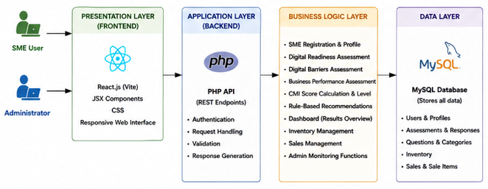

5.2 overall system design
The overall design of SME Digi combines the key functional elements needed to facilitate the digital assessment and decision support of SMEs in a single, web-based system. This system has two primary user roles: SME User and System Admin. SME users can interact with the platform via assessment, recommendation, dashboard, history, inventory, sales, and profile functions, and administrators can monitor assessment activities and SMEs through a separate interface.

The primary assessment process starts after an SME user chooses one of the three assessment types – Digital Readiness, Digital Barriers, or Business Performance. The system fetches general and specific questions to the business, validates entered answers, generates dimension scores, overall scores, and categorizes the answers based on the predefined categories. The calculated results are subsequently fed to the recommendation component based on rules to select appropriate recommendations for improvement. The database stores all relevant data, such as user data, test responses, scores, recommendation rules, inventory data, and sales data, which can be accessed via the respective system interfaces.

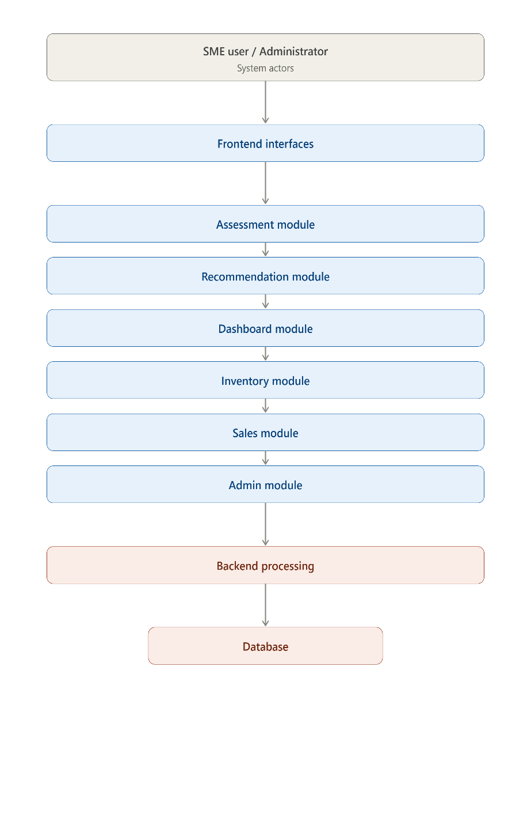

5.3 Use case Diagrams.
The Use Case Diagram shows the basic uses cases between two primary actors in the SME Digi - the SME User and System Administrator. The SME User accesses Assessment, Recommendation, Dashboard, Inventory, Sales and Profile-related functions and the System Administrator accesses the administrative monitoring functions.
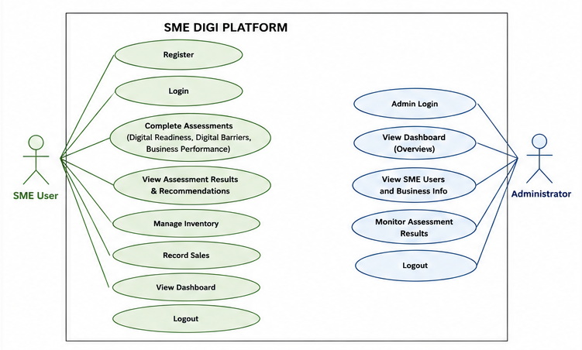

5.4 Class Diagram
The Class Diagram is the primary logical classes of the main objects in SME Digi and their relationships. There are the following major classes: SME, Administrator, Assessment Question, Assessment Session, Assessment Response, Assessment Score, Recommendation Rule, Inventory Item, and Sale.
An SME may take multiple assessment sessions, and each assessment session yields responses to assessment questions and assessment scores. The assessment score generated is then used along with pre-defined rules to make appropriate recommendations. The SME is also connected to the inventory and sales records. Inventory and sales are maintained as separate business-support functions within the current implementation. Automatic integration between sales, finished products, and raw-material inventory is considered a possible future enhancement.
The Administrator primarily is involved with the monitoring of SME users and assessment information. This diagram represents the main data and operations of the platform in an object-oriented way and is used to complement the behavioral information in the Use Case and Sequence diagrams.

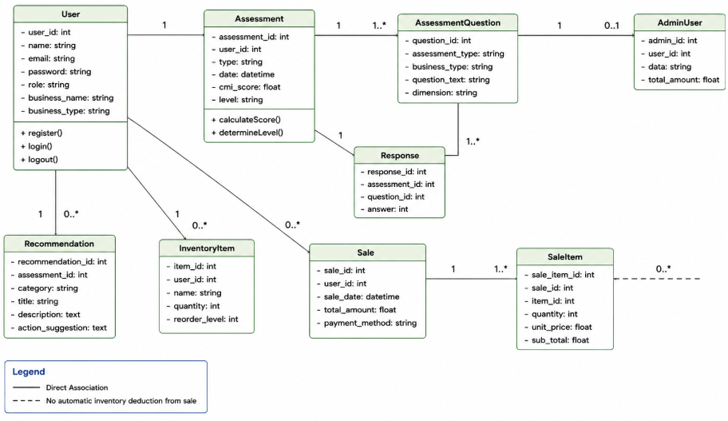

  - Sequence Diagrams

- Sequence 1 — Complete Digital Assessment
SME User → React Frontend → PHP API → Assessment Logic → MySQL

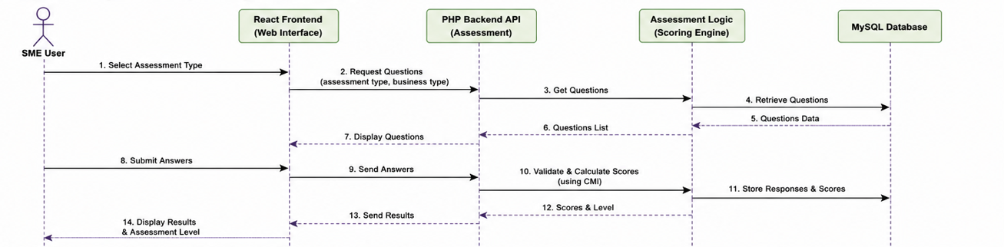

2.Sequence 2 — View Recommendations
SME User → React Frontend → PHP API → Rule-Based Recommendation Logic → MySQL

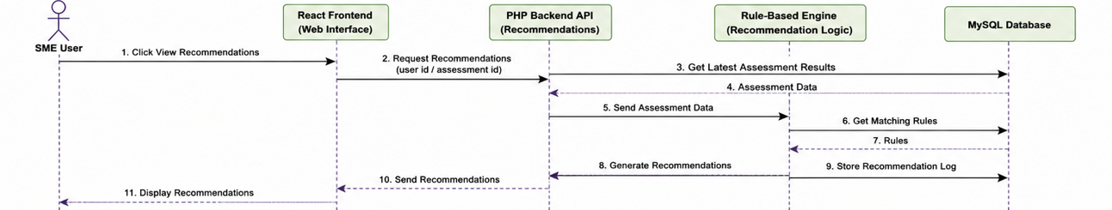

3.Sequence 3 — Admin Monitor Assessment Results
Administrator → React Admin Interface → PHP API → MySQL

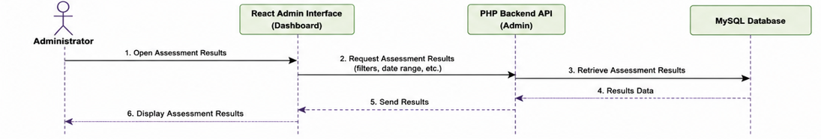

5.6 Activity Diagram
The Activity Diagram depicts the process an SME user completes as they fill out an assessment via the SME Digi platform. It starts with the SME user log in and choose the type of assessment. The system fetches the related common and business type specific questions and displays them to the user. Once responses are submitted and validated, the system produces relevant dimension scores and an overall Composite Mean Index (CMI) score. The outcome is subsequently categorized by the pre-defined assessment levels. Predefined rules are used to determine appropriate recommendations based on the assessment result. Last, the assessment result and recommendations are shown to the SME user.
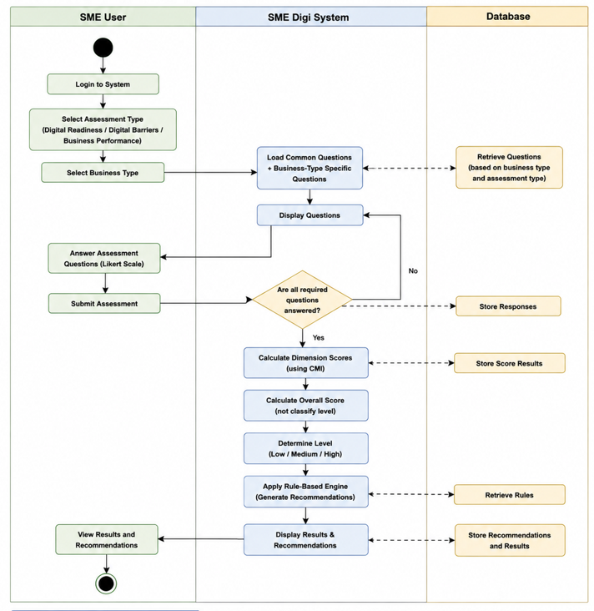
5.7 Entity Relationship (ER) diagram.

The Entity Relationship (ER) diagram shows the structure of the proposed SME Digi system, and the relationships between the primary data entities in the system. It contains data for SME and administration, assessment questions and answers, assessment results, recommendations, inventory records and sales information. The relationships between them and the consistency of data are established by primary/foreign keys. The diagram illustrates the primary functions of the system, such as assessing SME digital readiness, identifying digital barriers, evaluating business performance, generating rule-based recommendations, managing inventory and sales records, and supporting administrative monitoring
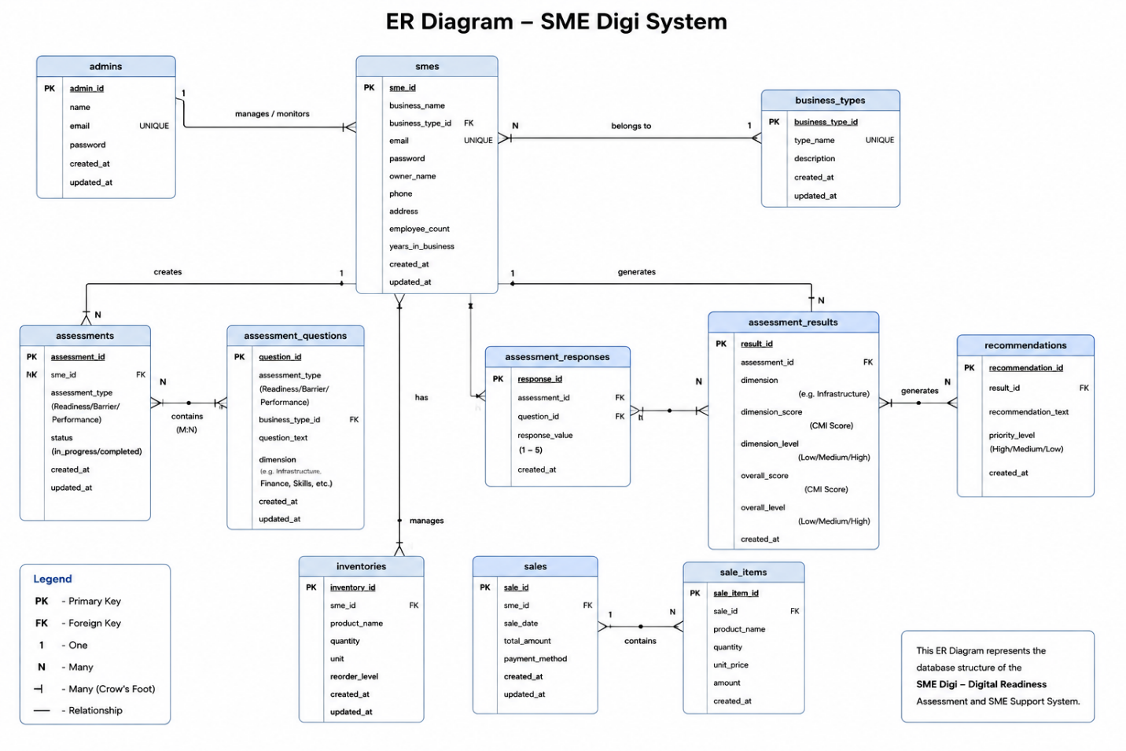

5.8 Data-Flow Diagram

Data Flow Diagrams (DFDs) are used to represent the flow of data between external entities, system processes, and data stores in a software system [27]. Data is mostly exchanged between the SME User/System Administrator, the system processing, and the database in SME Digi. Registration information, Assessment responses, Inventory information and Sales information are provided by SME users.
Assessment responses are fed into the assessment process to derive assessment scores and assessment classification which is then utilized by the rule-based recommendation process. Processed information and related files or records are stored in the database and pulled when needed by the dashboard, history, recommendation and administrative monitoring functions.

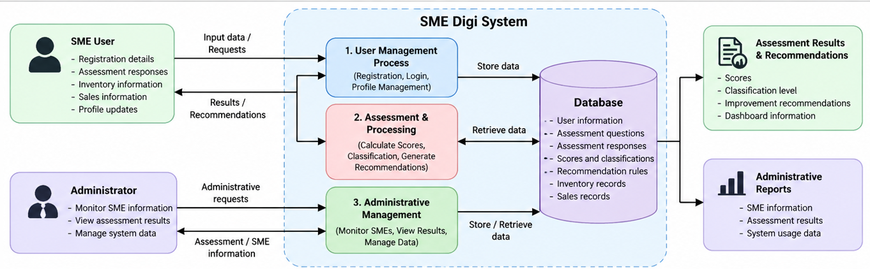

5.9 User Interface Design
User interface design plays a crucial role in the development of usable web applications and in ensuring satisfactory interaction between the users and system functions [28]. The SME Digi user interfaces were developed to be simple and understandable – offering easy access to the primary system functions.
The SME User interface gives access to the dashboard, Digital Readiness, Digital Barriers and Business Performance assessments, recommendations, assessment history, inventory, sales and profile functions. The assessment interfaces are scored on a 5-point scale, and results are reported by scores and classification levels. There is an additional administrator interface to monitor the registered SMEs and assessment results.

Digital Assessment Interface

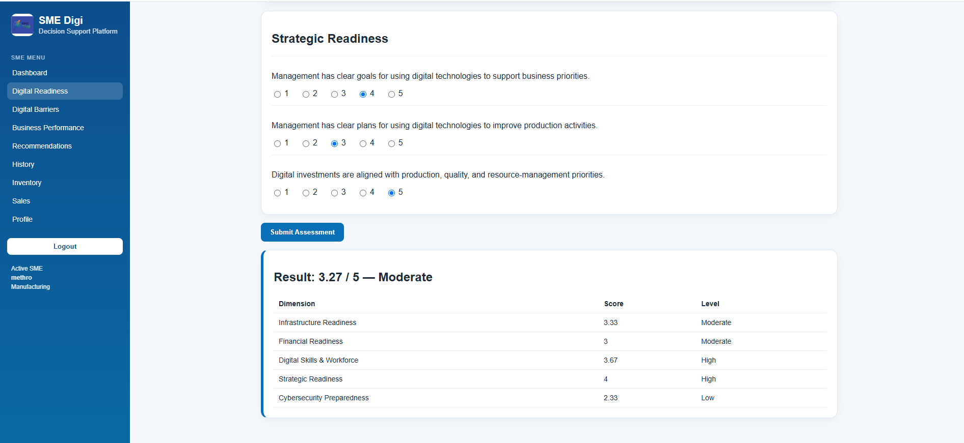

Administrator Dashboard Interface

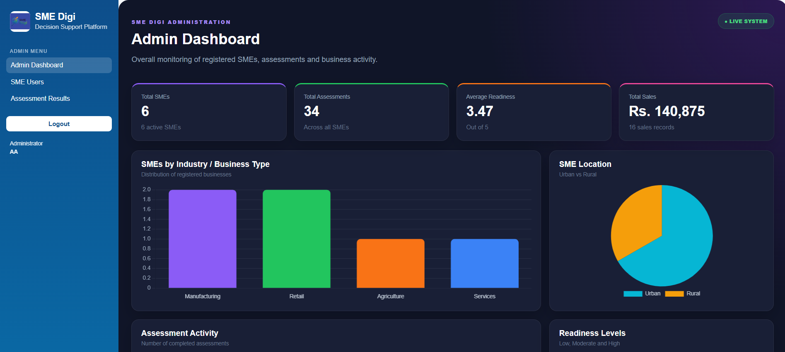
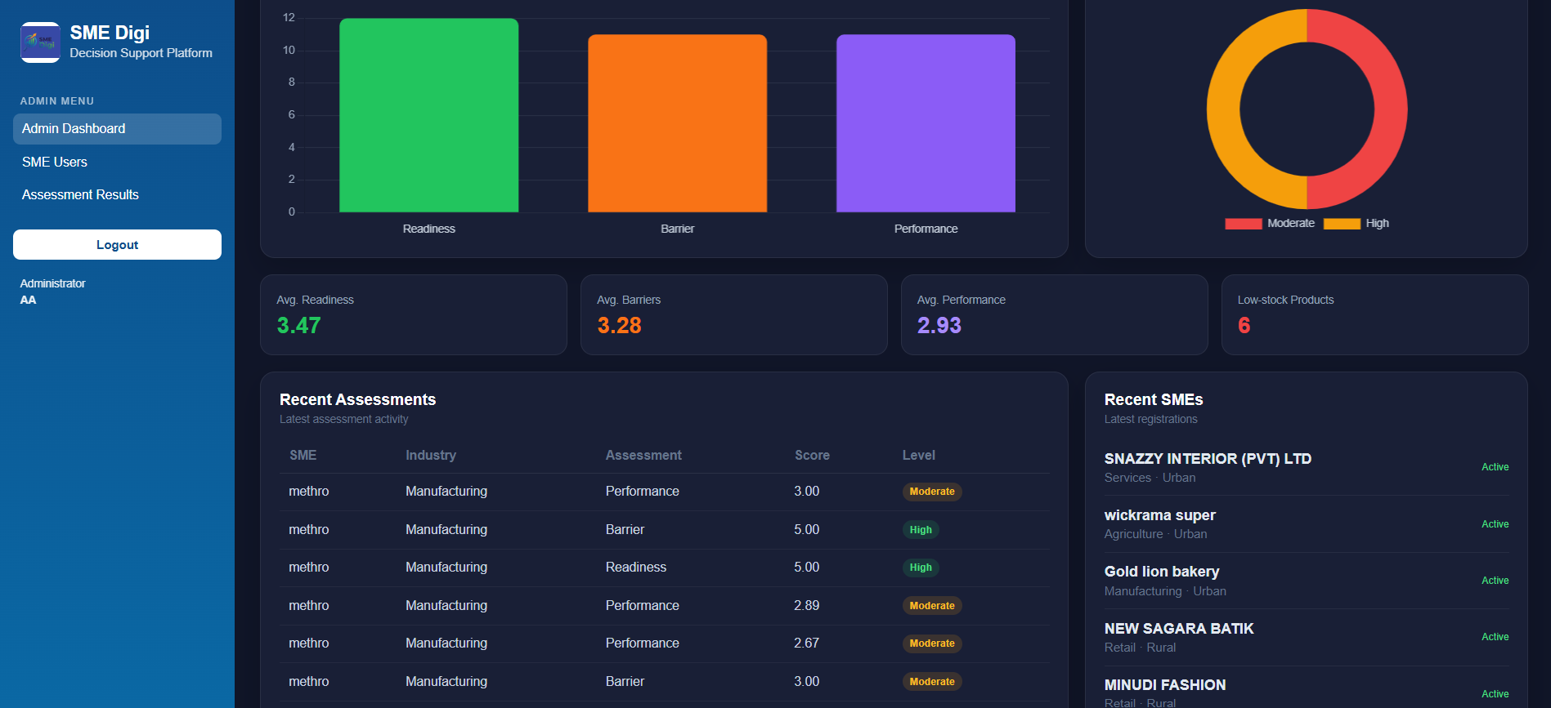

SME Digi SME Dashboard Interface

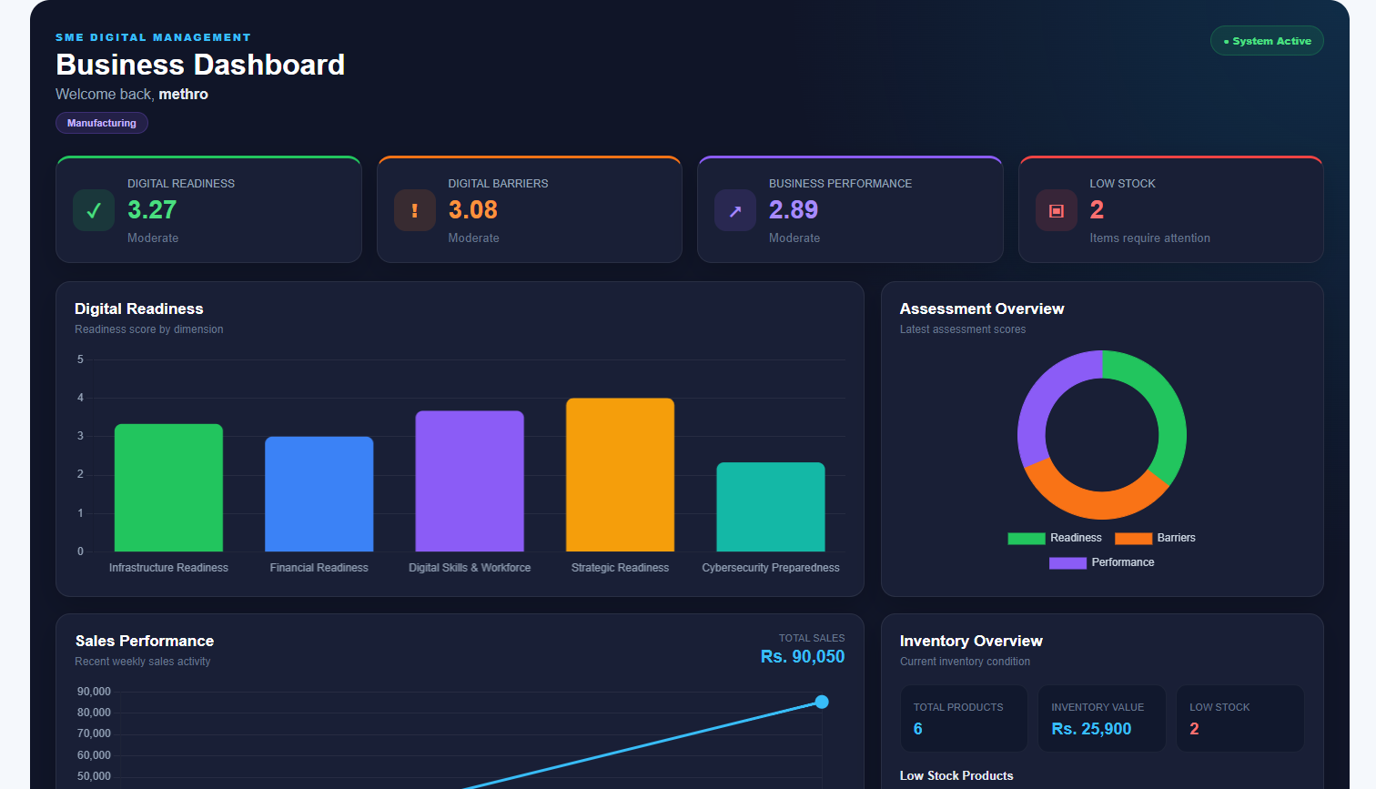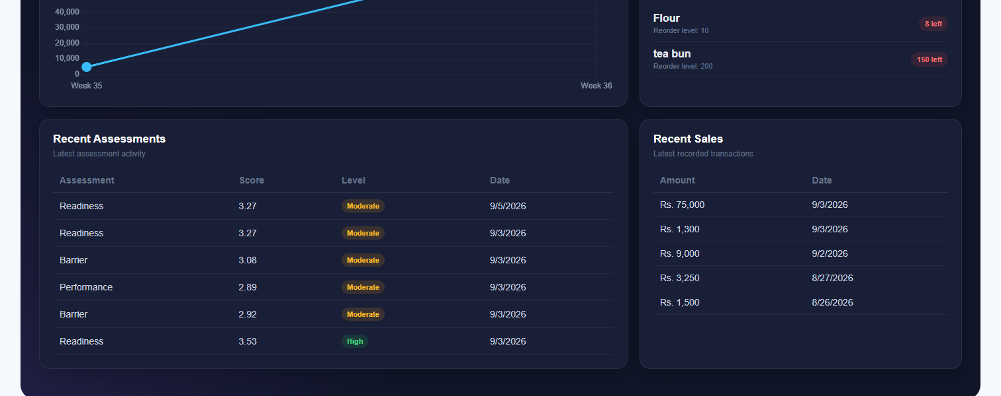

Recommendation Interface

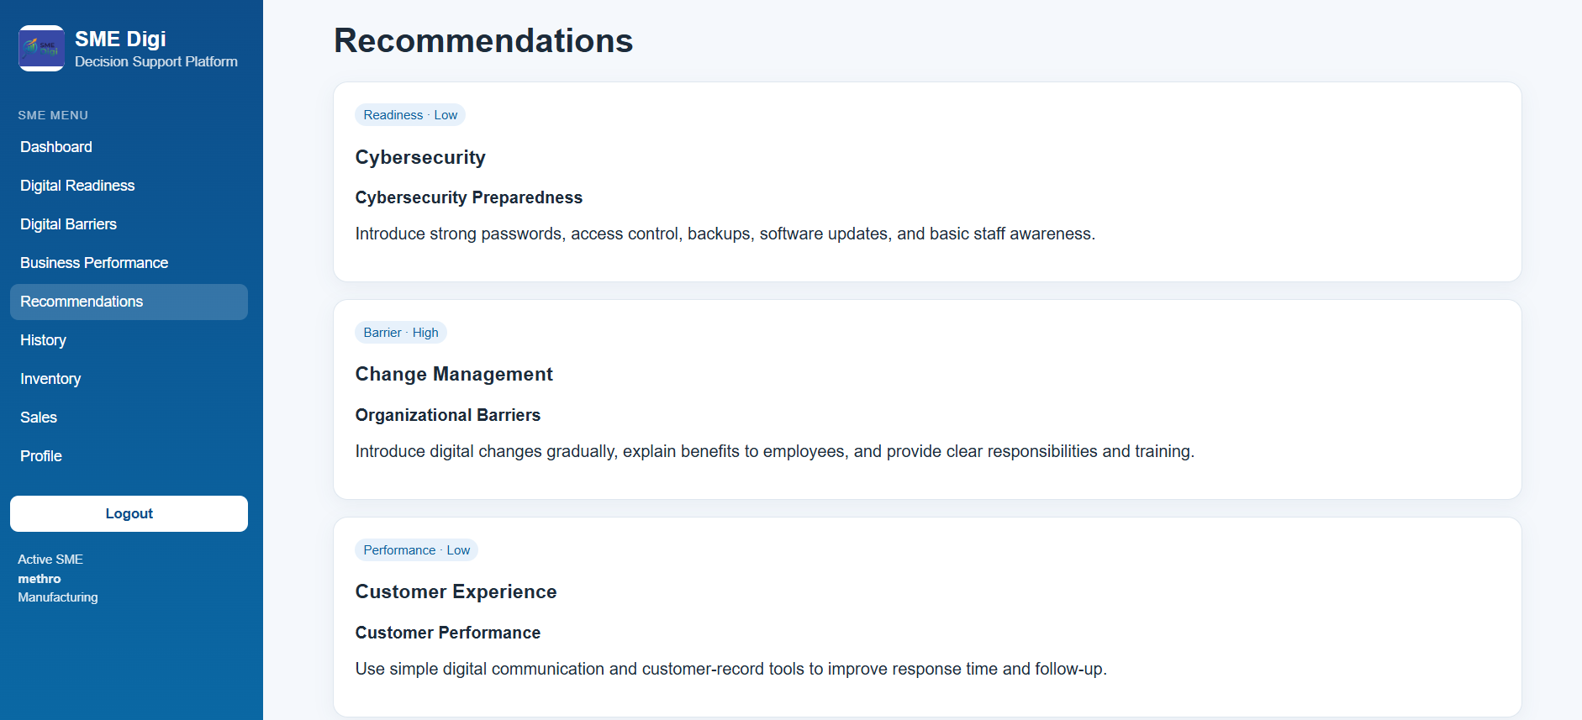

5.10 Component/Module Design
Component-based software design is a method which assists in organizing software functions and controlling the complexity of a system, and therefore in software development and maintenance [29].

SME Digi is split into a number of functional modules based on the major responsibilities of the system. The Authentication and User Management Module manages the authentication and user information of SMEs and administrators. Common and business type specific questions are included with Digital Readiness, Digital Barriers, and Business Performance assessments within the Assessment Module. The Scoring and Classification Module (SCM) is used to score dimensions and overall scores and to assign a classification level. The Rule Based Recommendation Module compares the results of the assessment with a set of rules to get appropriate recommendations.

The Dashboard and Assessment History Module presents the latest assessment information and previous assessment results. Inventory Module and Sales Module are basic business support modules to record and manage inventory and sales data. Lastly, the Administrator Monitoring Module lets administrators see registered SMEs and view assessment results.

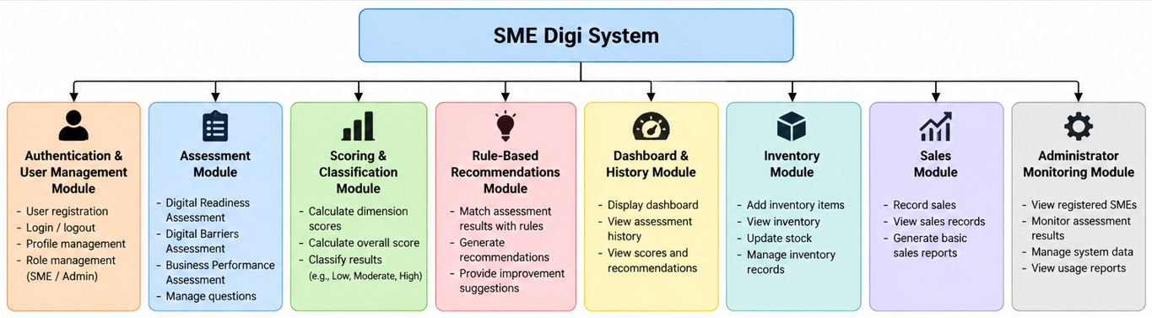

5.11 Security Design
SME Digi security design emphasizes access control and data security of the system via user authentication, password authentication, user role separation, data input validation, and session management. Each SME user/administrator authenticates via a different system function and passwords are stored as password hashes, not in plain text. The PHP session is used to hold authenticated sessions for the user.
Role separation means that SME users do not have access to the administrator functions and that only authenticated administrators have access to the administrator functions. The input is also validated when handling vital input data from the user, such as the responses in the assessments and authentication data.

Security Area | SME Digi Design
Authentication | Separate SME User and Administrator authentication
Password Security | Password hashing
Session Management | PHP session-based authentication
Access Control | Separation of SME User and Administrator functions
Input Validation | User-submitted data is validated before processing

5.12 Design Decisions and Justification
The following are some of the design decisions made based on the SME Digi's objectives, requirements and scope. A web based approach was chosen, accessible with a standard web browser. For the front end, React.js, Vite, JSX and CSS were chosen, for the back end/API processing, PHP and for persistent data storage, MySQL/MariaDB.
The CMI based scoring mechanism was chosen to deliver the numerical assessment scores and classification levels. Recommendations based on rules were chosen to give transparent recommendations based on certain pre-defined assessment conditions without the use of Artificial Intelligence or Machine Learning. To make assessment more relevant for various SMEs, assessment questions were added, which were specific to the businesses. To differentiate between normal SME use and administrative monitoring activities, there was also a separation of the roles of SME User and SME Administrator.

Design Decision | Selected Approach | Justification
Application type | Web-based system | Accessible through a standard web browser
Frontend | React.js, Vite, JSX, CSS | Supports interactive and component-based interfaces
Backend | PHP | Handles APIs and server-side processing
Database | MySQL/MariaDB | Supports structured storage of SME Digi data
Assessment method | CMI-based scoring | Provides numerical dimension and overall assessment scores
Recommendation method | Rule-based | Provides recommendations based on predefined conditions
Question selection | Common + business-type-specific | Makes assessments more relevant to different SMEs
User access | SME User + Administrator | Separates SME functions from administrative monitoring

CHAPTER 06 – IMPLEMENTATION

6.1 Chapter Overview
This chapter illustrates implementation of the SME Digi Digital Readiness Assessment (DDR), and SME Support System (SS) with reference to the requirements and system design presented in the previous chapters. It describes the development environment, technologies and frameworks used, the various modules implemented on the system, how database was implemented, backend and frontend development, how APIs were integrated, security mechanisms implemented and the key implementation decisions.
The implementation mainly focuses on the three digital assessments: Digital Readiness, Digital Barriers, and Business Performance. The system further includes CMI based score calculation and categorization, rule-based recommendation, dashboards, assessment history, basic inventory and sales management and administrative monitoring.

6.2 Development Environment
SME Digi has been developed and tested locally. Source code development was done using Visual Studio Code, along with source code management. The required local Apache and MySQL/MariaDB environment for the backend and database was set up using XAMPP.
The React frontend was run using the Vite development server and PHP APIs were run using the Apache server. MySQL/MariaDB was used for persistent data storage. This enabled the frontend, backend and database components to be built and tested concurrently, before going to a production environment.
Development Component | Technology/Tool
Code Editor | Visual Studio Code
Local Server | XAMPP / Apache
Frontend Development Server | Vite
Frontend | React.js, JSX, CSS
Backend | PHP
Database | MySQL/MariaDB
Database Management | phpMyAdmin
Web Browser | Modern web browser

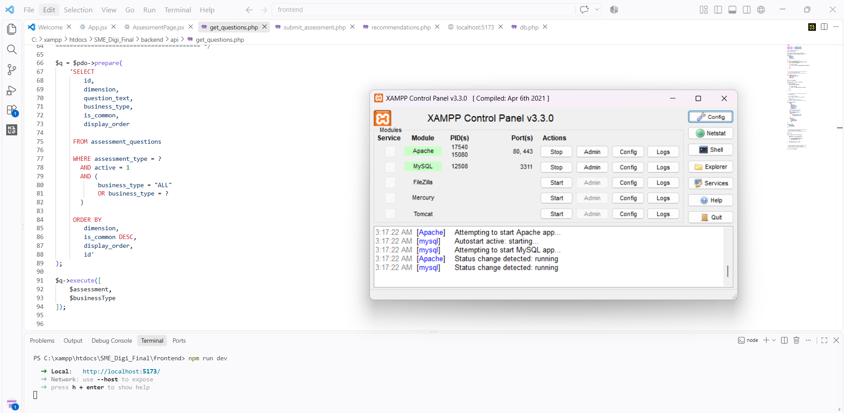
6.3 Technologies and Frameworks
SME Digi's front end was built with React.js, Vite, JSX and CSS. The user interface was structured using React.js and the frontend development environment was set up with Vite. JSX was used to define interface structures and CSS was used for interface styling.

PHP was used to undertake the server-side processing as well as building API endpoints.The development of API endpoints and the server-side processing are part of PHP. It handles authentication, retrieval of assessment questions, handling of assessment responses, scoring, providing recommendations, inventory and sales processing, and more. System information was stored in a relational database, which in this case was MySQL/MariaDB.

Technology | Application in SME Digi
React.js | Development of interactive frontend interfaces
Vite | Frontend development and execution
JSX | Structure of React interfaces
CSS | Interface styling
PHP | Backend processing and API development
MySQL/MariaDB | Persistent data storage
XAMPP | Local Apache and database environment

6.4 System Modules
SME Digi is broken down into multiple functional modules for implementation. These modules are used to implement both the assessment and SME-support part of the system. The Authentication and User Management Module provides SME and administrator registration, login, logout, profile information and authenticated sessions. The Assessment Module will handle the Digital Readiness, Digital Barriers and Business Performance assessments and fetch the relevant questions based on the assessment type and registered business type.
The Scoring and Classification Module scores the dimensions and overall score and applies the predefined classification. The Rule Based Recommendation Module leverages the assessment results and pre-defined rules to give all the relevant recommendations for improvements. The Dashboard and History Module shows the latest assessment information and prior assessment results. The Inventory and Sales Modules offer fundamental business-support functions and the Administrator Monitoring Module allows administrators to keep track of registered SMEs and assessment results.
6.5 Database Implementation
MySQL/MariaDB has been used for the implementation of SME Digi database. The database holds user information for both SMEs and administrators, assessment questions, assessment sessions, individual assessment answers, assessed scores, recommendation rules, inventory data and sales data.
The primary system databases that are implemented are
smes admins assessment questions, assessment sessions assessment responses assessment scores, recommendation rules inventory sales

Where appropriate, the main assessment and the SME records are related via primary and foreign keys. Assessment information can be stored in the database following submission and retrieved later for dashboards, assessment history, recommendations, administrative monitoring and more.
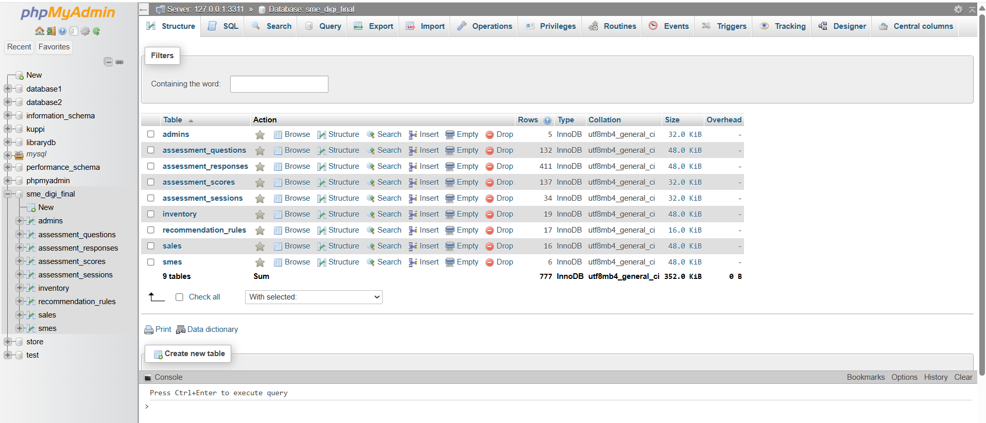

6.6 Backend Implementation

The backend of SME Digi was implemented using PHP. PHP API files receive requests from the React frontend, validate the supplied information, perform the required processing, interact with the MySQL/MariaDB database, and return the required information to the frontend.

6.6.1 Dynamic Assessment Question Selection

The Assessment questions are recalled based on the type of assessment that is selected and the registered business type of SME. Common and business type specific questions are both returned by the system. This enables different SMEs to be given questions that are more pertinent to their business environment.

get_questions.php

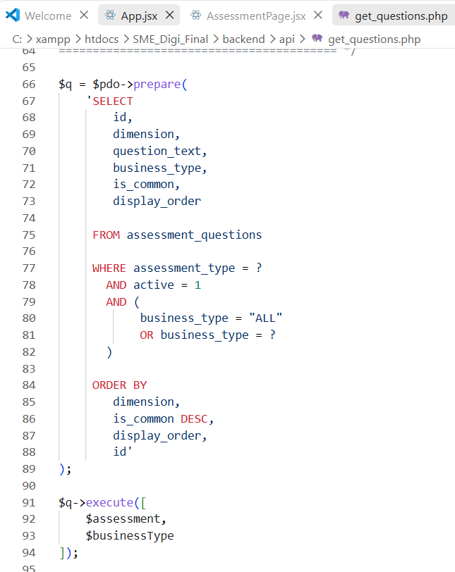

6.6.2 Assessment Score Calculation

The responses from the SME users in those three assessment modules are fed to the assessment score calculation algorithm. All questions are specific to an assessment dimension and are measured on a 5-point Likert scale. Respondents are then sorted by dimension and the mean score for each dimension is computed.

The Composite Mean Index (CMI) for a particular dimension is calculated using Equation.

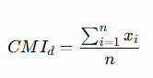

where $CMI_{d}$represents the Composite Mean Index of dimension $d$, $x_{i}$represents the response value assigned to a question, and $n$represents the number of questions included within the respective dimension.
After calculating the individual dimension scores, an overall assessment score is calculated from the relevant dimension scores using Equation.

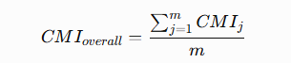

where $CMI_{overall}$represents the overall assessment score, $CMI_{j}$represents the calculated score of each assessment dimension, and $m$represents the total number of dimensions included in the assessment.

submit_assessment.php
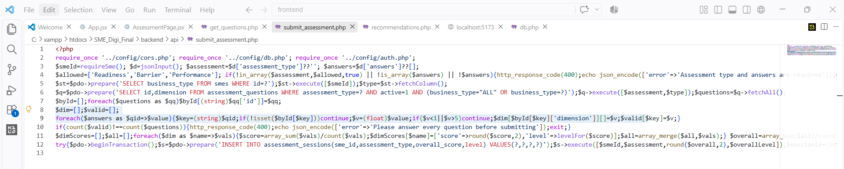

6.6.3 Assessment Classification
After calculating the assessment scores, the system determines the corresponding classification according to the predefined CMI ranges.
CMI Range | Classification
1.00 – 2.60 | Low
2.61 – 3.40 | Moderate
3.41 – 5.00 | High

For Digital Readiness and Business Performance, a higher score represents a stronger condition. For Digital Barriers, a higher score represents a higher level of barriers.

6.6.4 Rule-Based Recommendation Implementation
The recommendation mechanism was implemented using predefined rules rather than Artificial Intelligence or Machine Learning. Once the assessment results are calculated and classified, it can combine the information, including the type of assessment, the dimension of assessment, the classification, and the business type, to match the recommendation rules.

Identified recommendations are then pushed back to the SME user in the Recommendations interface. This approach makes the recommendation process transparent because recommendations are determined using explicitly defined assessment conditions.

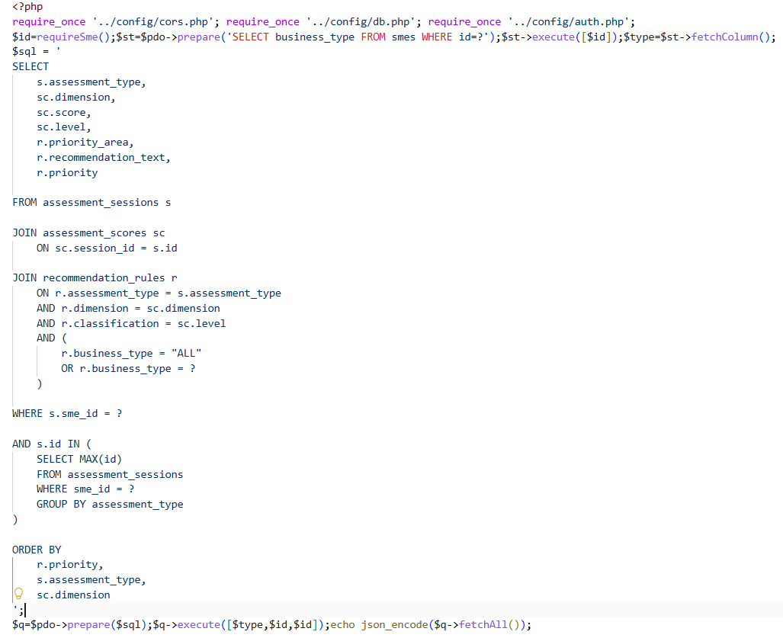

6.7 Frontend Implementation.
The front-end was built in React.js, JSX and CSS. Three different interfaces were developed: public pages, SME User functions, and Administrator functions. To display information about the system and to communicate with the PHP back-end, react components are used. Dynamic display of the questions in the assessment interface based on information returned from the backend.

Each assessment question has a five-point response scale. Once they submit, the calculated scores and classification levels that the backend returns are shown to the user. The SME Dashboard, Recommendations, Assessment History, Inventory, Sales, Profile, and Administrator Dashboard are among the other frontend interfaces.

Dynamic Assessment Question Display Implementation

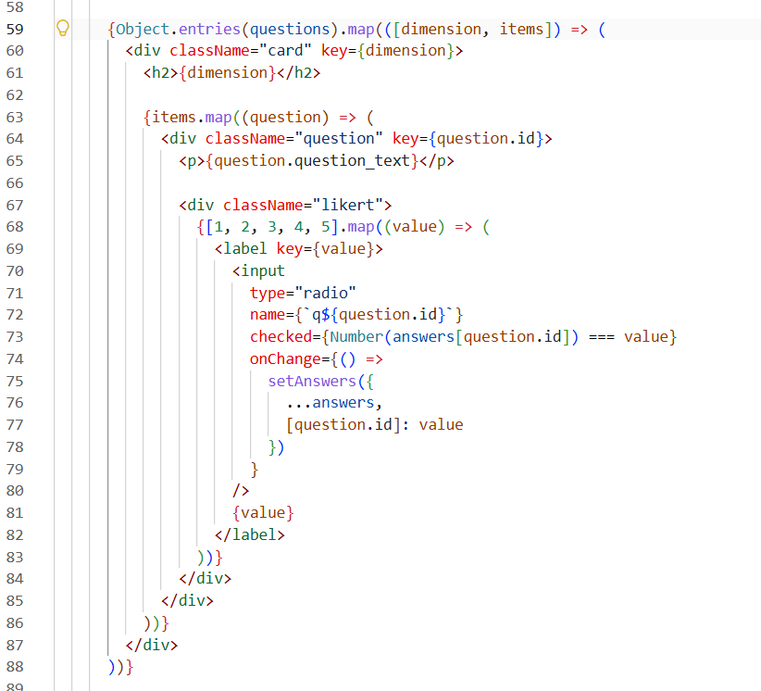

6.8 API and Integration Implementation
API requests are used for communication between the React frontend and PHP backend. The frontend makes requests to the relevant PHP endpoints and the backend processes the request, interacts with the database, and returns data in JSON format. The API layer enables authentication, profile management, the retrieval of assessment-questions, the submission of the assessments, recommendations, dashboard information, assessment history, inventory management, sales management, and administration monitoring.

Integration establishes the following overall communication flow:
React Frontend → PHP API → Business Processing → MySQL/MariaDB → PHP API → React Frontend

The session credentials are provided along with authenticated requests coming from the front end and the backend can use these to know whether the request is from an authenticated SME User or an Administrator.
Figure 6.8: Frontend and Backend API Integration Code
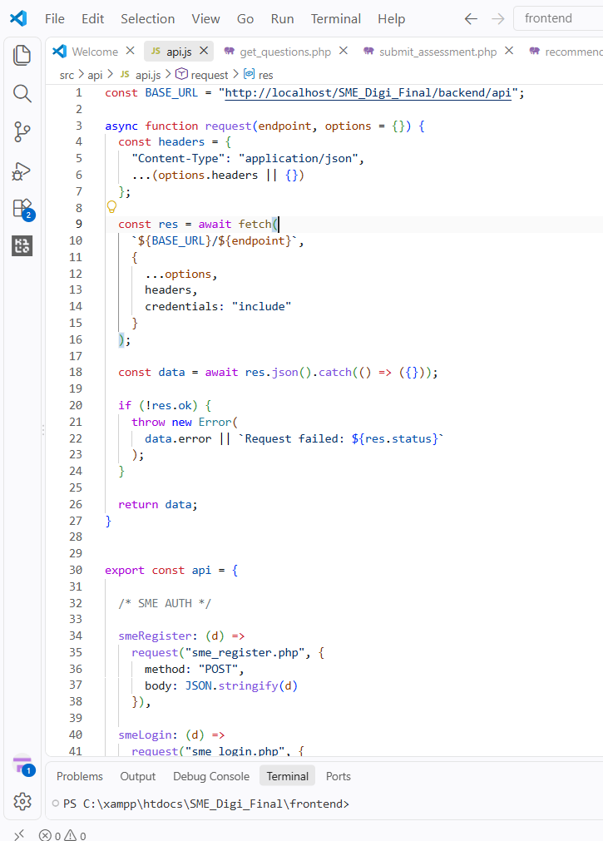
6.9 Security Implementation
Access to SME Digi was secured and user information protected with security mechanisms. Appropriate handling of areas including authentication, sessions, passwords and input validation is essential to web application security [30].

User authentication and Admin authentication are split based on respective roles of User and Admin. Passwords are not stored in plain text, but rather through password hashing. For authenticated sessions, PHP sessions are used, and for authenticated functions, protected functions are used in the backend to check whether the user has an authenticated role or not. Important data that is submitted is also validated before it is processed. While client-side input validation can be fooled, server-side validation is very critical.

Security Mechanism | Implementation
Authentication | Separate SME User and Administrator login
Password Protection | Password hashing
Session Management | PHP sessions
Role Separation | SME and Administrator access restrictions
Input Validation | Validation before backend processing

6.10 Key Implementation Decisions
To ensure the developed system aligned with the research goals, several implementation decisions were made. It was decided to implement a web application so that the SME owners/managers can use the application via a standard browser. React and PHP APIs were used to split the frontend from the backend, and MySQL/MariaDB to offer structured persistent storage.

Common questions were combined with business-type specific questions in the assessment, with dynamic question selection implemented. The new system of scoring is based on CMI to give the assessment results numerically, and the classifications are provided as a guideline for interpretation of the numerical scores.

The decision logic was chosen to be rule-based to ensure transparency of the recommendations and to ensure that decisions are understandable. In the current implementation, inventory and sales functions are lightweight functions that are independent from each other. Hence, entering a sale doesn't automatically reduce the inventory levels.

6.11 Implemented System Interfaces
The main SME Digi interfaces, including the SME Dashboard, Digital Assessment Interface, Recommendation Interface, and Administrator Dashboard, were presented in Section 5.9 as part of the user interface design. This section presents additional implemented interfaces that demonstrate the supporting functions of the completed system.
Figure 6.X: SME Digi Landing Page
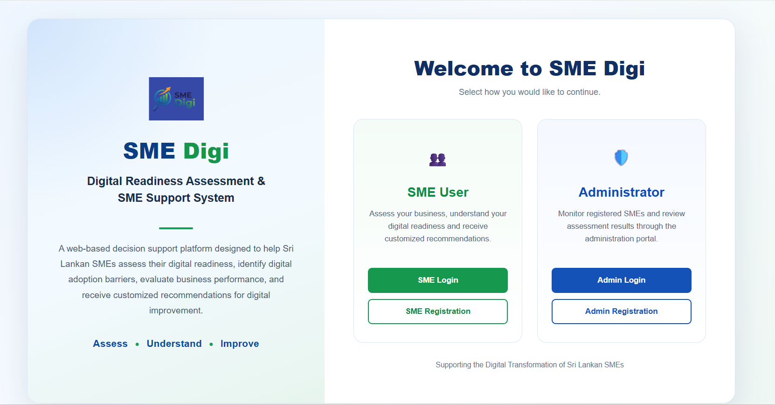
Figure 6.X: Assessment History Interface
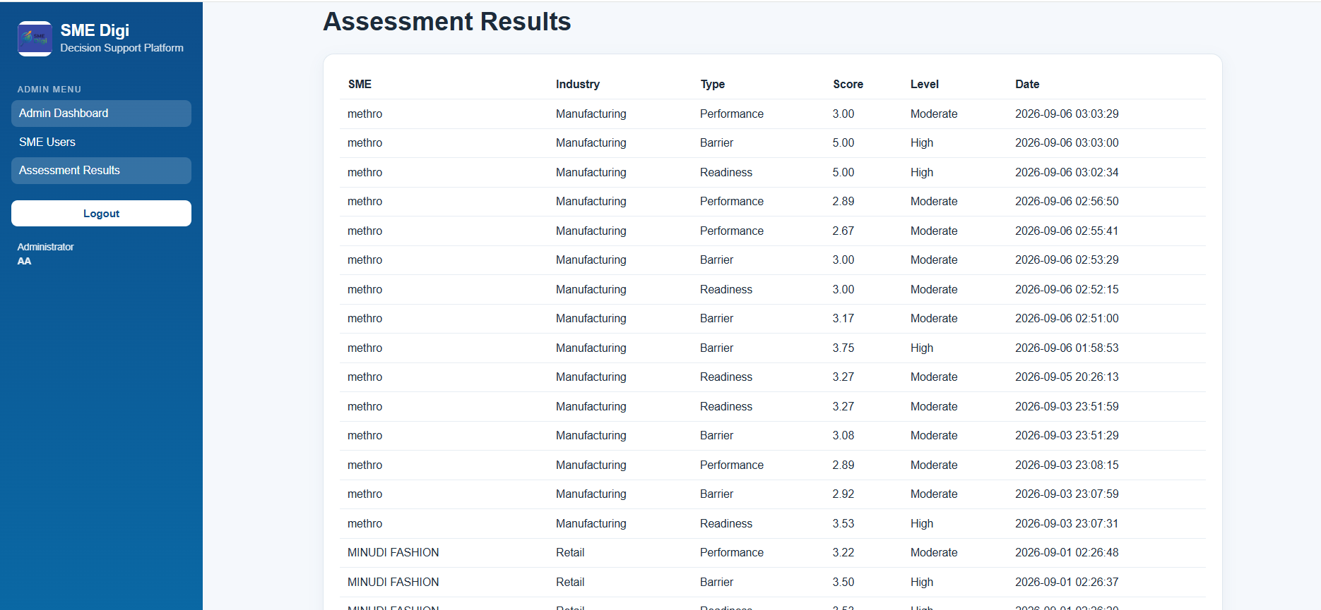

Figure 6.X: Inventory Management Interface

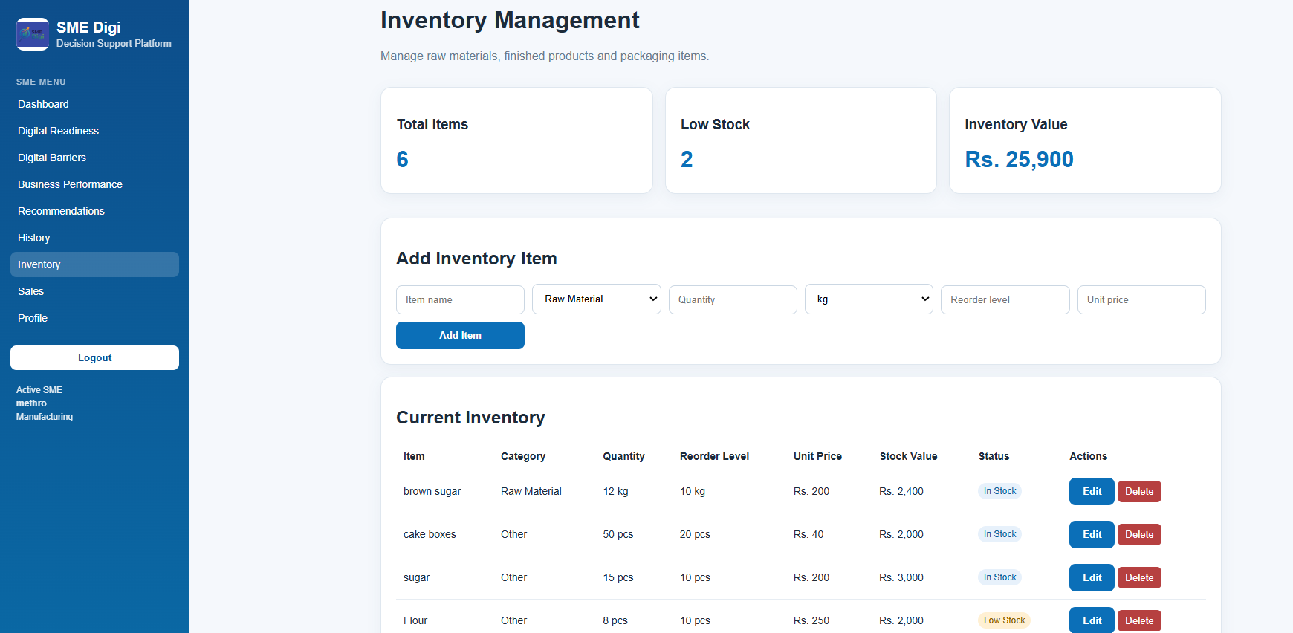

Figure 6.X: Sales Management Interface

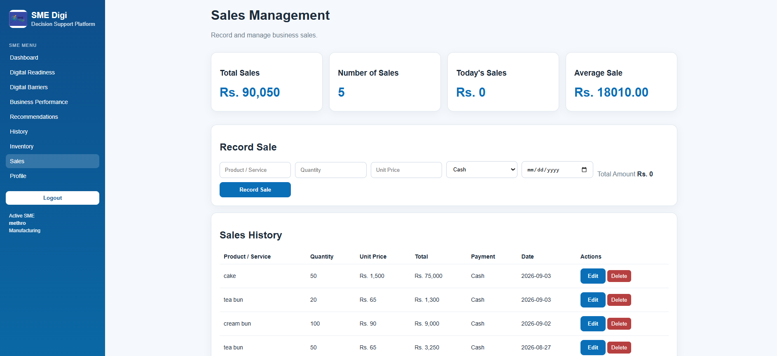

6.12 Chapter Summary
This chapter outlined the processes for the implementation of the SME Digi Digital Readiness Assessment and SME Support System. React.js, Vite, JSX, CSS, PHP, MySQL/MariaDB and XAMPP are used to implement this system. It involves the use of user authentication, the selection of assessment questions based on CMI, the calculation of scores based on the CMI, the classification of the assessments based on the rules, the generation of recommendations based on the rules, the monitoring of the score by the administrator, the creation of assessment history, and inventory and sales functions.

The chapter also outlined database implementation, frontend and backend development, API integration, and security mechanisms. The current recommendation mechanism has been defined in rules and for this reason, AI and Machine Learning were not implemented. The interfaces that were implemented show how the system design outlined in chapter 5 has been translated into SME Digi prototype, which is a functional implementation
CHAPTER 07 – TESTING AND EVALUATION
7.1 Chapter Overview
This chapter presents the testing and evaluation of the SME Digi system. The intent of testing is to ascertain if the implemented system behaves as per set requirements and whether its key functions are delivering the desired outcome.
Main functional and non-functional aspects relevant to SME Digi are analyzed, such as the process of evaluation, calculation of the CMI, rule-based recommendations, performance of the system and its compatibility, its usability, security and the system functions supported. This is used to determine what features have been successfully implemented, as well as any limitations and things that need to be improved on.

7.2 Testing Strategy

The SME Digi system was subjected to testing to determine if it meets its functional and non-functional requirements. As SME Digi is a web-based decision-support system, the major testing strategy involved mainly assessment workflow, scoring and classification mechanism, recommendation generation, information retrieval, system performance, compatibility and supporting business functions.
A functional and non-functional testing method was considered. The individual system function was tested to validate the output of the system for a specific input using functional testing. Non-functional testing was conducted on the characteristics of the system, which included responding time, interface responsiveness, browser compatibility, usability, and security-related behavior [31].
Testing has been done in the local development environment for SME Digi. The results shown in this chapter are thus the result of the prototype's performance as deployed locally here and should not be viewed as results of its performance as a production server.

Table 7.1: Summary of Sele
cted SME Digi Test Cases

Test Case ID | Test Area | Testing Type | Objective
TC01 | System Response Time | Non-Functional | Evaluate response time of selected major system operations
TC02 | Responsive Interface | Non-Functional | Verify that major interfaces remain usable at different screen sizes
TC03 | Browser Compatibility | Non-Functional | Verify the operation of SME Digi in selected browsers
TC04 | Dynamic Assessment Questions | Functional | Verify common and business-specific question selection
TC05 | Assessment Submission | Functional | Verify successful assessment completion and submission
TC06 | CMI Calculation | Functional | Verify accuracy of dimension and overall assessment calculations
TC07 | Assessment Classification | Functional | Verify correct Low, Moderate, and High classification
TC08 | Recommendation Generation | Functional | Verify correct rule-based recommendation matching
TC09 | Dashboard and Assessment History | Functional | Verify correct retrieval and presentation of assessment results
TC10 | Inventory and Sales | Functional | Verify the major supporting inventory and sales operations

These test cases provide focused coverage of the main contribution and supporting functionality of SME Digi rather than attempting to test every individual interface operation.

7.3 Unit Testing

The Unit-level testing was conducted on one important processing function in each unit in SME Digi. The calculation and classification logic was given special consideration, as it could impact the assessment result and recommendations for subsequent years.
The value calculated by the CMI was checked by comparing the manually calculated value to the calculated value obtained from the system, and by comparing the value with the expected value. For instance, if someone enters 4, 3 and 2, the mean score is expected to be 3.00, and this is also the score returned by SME Digi.
Boundary values were also tested for the classification mechanism. The classification ranges implemented were:

CMI Score | Classification
1.00 – 2.60 | Low
2.61 – 3.40 | Moderate
3.41 – 5.00 | High

The values at and close to the classification boundaries were tested to see if the correct classification was returned. The tested boundary values included 1.00, 2.60, 2.61, 3.40, 3.41, and 5.00. For Digital Readiness and Business Performance, a higher classification represents a better condition. A higher Digital Barriers classification is a higher level of barriers.

7.4 Integration Testing
Integration testing performed to check how the front end interfaces, PHP back end APIs, assessment processing logic and the MySQL/MariaDB database communicate.

The dynamic assessment process was an important factor of integration. When the SME user logs in to an assessment, the assessment frontend asks the assessment backend what questions should be displayed. The system determines the type of assessment and the type of registered business and fetches the relevant common questions and business specific questions. Once a user's responses are submitted, they are worked through and saved, and then the results are displayed to the user.

The recommendation process was also another point of integration of importance. Assessment information is correlated with defined assessment recommendation rules based on assessment type, dimension and classification, as well as business type. The appropriate recommendation is then fetched and shown via the user interface. This capability was examined in the context of the recommendation generation test.

7.5 System Testing
The web-based application SME Digi was tested in a system test and not on each component individually. Major user workflows were tested from the user interface to the backend processing through the interaction with the database.

The assessment functions—Digital Readiness, Digital Barriers, and Business Performance, along with dashboard information, assessment history, recommendations, inventory and sales functions—were evaluated. Google Chrome and Microsoft Edge browsers were also tested. All the main functions tested in both selected browsers worked properly. System level testing was special to ensure that the individual parts of the system developed in the implementation stage worked as a whole system SME Digi system.

7.6 User Acceptance and Usability Evaluation

Usability evaluation focused on the understandability and usability of the primary user interfaces of the SME Digi system for the main system functions. Navigation, assessment forms, dashboard information, tables, recommendations, and supporting interfaces were specifically looked at.
Additionally, responsiveness of the interface was assessed with various screen sizes. Existing evaluation indicated that the interfaces tested were working as expected in the laptop/desktop environment, but were not working as expected on the tested mobile device. Hence, the present implementation did not have full mobile coverage.
This is a usability limitation that has been identified but not hidden during the evaluation process. Improving responsive behaviour and accessibility of the mobile devices is therefore deemed an area for improvement in the future.

7.7 Test Cases and Results

The detailed functional and non-functional test cases were executed to determine whether the selected system operations produced the expected results.
7.7.1 Non-Functional Testing
TC01 – System Response Time Testing.
Table 6.2: System Response Time Test

Test Item | Test 1 (ms) | Test 2 (ms) | Test 3 (ms) | Average (ms) | Status
Load SME Dashboard | 28 | 38 | 47 | 37.67 | Pass
Load Assessment Questions | 40 | 37 | 13 | 30.00 | Pass
Sales | 10 | 28 | 22 | 20.00 | Pass
Load Recommendations | 89 | 52 | 64 | 68.33 | Pass
TC02 – Responsive Interface Testing

Interface | Laptop | Mobile Phone | Expected Result | Actual Result | Status
Landing Page | Pass | Fail | Interface should work on both devices | Works correctly on laptop but not properly on mobile | Fail
SME Dashboard | Pass | Fail | Dashboard should be accessible on both devices | Works correctly on laptop but not properly on mobile | Fail
Assessment Page | Pass | Fail | Assessment should be usable on both devices | Works correctly on laptop but not properly on mobile | Fail

The device compatibility test showed that the SME Digi system functions correctly in the laptop/desktop environment. However, the system was not fully functional on the tested mobile device. Therefore, the mobile compatibility requirement was not achieved during the current implementation. Improving mobile responsiveness and mobile-device accessibility is identified as an area for future improvement.

TC03 – Browser Compatibility Testing

Browser compatibility is an important consideration for web-based applications because their operation may vary across different browsers and execution environments [33]. Therefore, browser compatibility testing was conducted for SME Digi using Google Chrome and Microsoft Edge.

Table 6.4: Browser Compatibility Test

Function | Google Chrome | Microsoft Edge | Expected Result | Status
Landing Page | Loaded correctly | Loaded correctly | Interface loads correctly | Pass
SME Login | Login successful | Login successful | User can authenticate successfully | Pass
Digital Assessment | Questions displayed and submission worked | Questions displayed and submission worked | Assessment operates correctly | Pass
Dashboard | Data and scores displayed correctly | Data and scores displayed correctly | Dashboard information is displayed | Pass
Recommendations | Recommendations displayed based on assessment result | Recommendations displayed based on assessment result | Recommendations are displayed correctly | Pass

7.7.2 Functional Testing.
TC04 – Dynamic Assessment Question Selection.
The common assessment questions and the business-specific questions are all included in SME Digi. Hence, the aim of this test was to ensure that the system can recognize the registered business type of the SME and retrieve the appropriate set of questions.

Table 6.5: Dynamic Assessment Question Selection Test
Test Attribute | Description
Test Case ID | TC04
Test Objective | Verify correct retrieval of common and business-specific questions
Precondition | SME User is logged in and has a registered business type
Test Action | Select and open an assessment
Expected Result | Common questions and questions applicable to the SME business type are displayed
Actual Result | displayed as expected result
Status | Pass

TC05 – Assessment Submission
This test checks if an SME user is able to complete and submit an assessment and if the data submitted is processed and stored by the system.

Table 6.6: Assessment Submission Test
Test Attribute | Description
Test Case ID | TC05
Test Objective | Verify successful completion and submission of an assessment
Precondition | SME User is logged in and the assessment questions are available
Test Action | Answer the required questions and submit the assessment
Expected Result | Responses are accepted, processed, and stored successfully
Actual Result | displayed as expected result
Status | Pass

TC06 – CMI Score Calculation
The accuracy of the CMI calculation is crucially important because the scores calculated will be utilized by later classification and recommendation functions. Thus, a test case was calculated by hand and the result from SME Digi was compared.

Table 6.7: CMI Calculation Verification
Test Attribute | Result
Test Case ID | TC06
Input Values | 4, 3, 2
Manual Calculation | (4 + 3 + 2) / 3
Expected Result | 3
System Result | displayed as expected result - 3
Difference | No difference
Status | Pass

TC07 – Assessment Classification
Once the assessment score is calculated, SME Digi classifies it into one of three categories – Low, Moderate, or High. The transitions between these ranges of classification were checked by boundary testing.
The following classification ranges have been implemented:

1.00–2.60 = Low
2.61–3.40 = Moderate
3.41–5.00 = High
The boundary values were chosen as they directly test the transitions between classification levels.
Table 6.8: Assessment Classification Test

Input Score | Expected Classification | Actual Classification | Status
1.00 | Low | Low | pass
2.60 | Low | Low | pass
2.61 | Moderate | Moderate | pass
3.40 | Moderate | Moderate | pass
3.41 | High | High | pass
5.00 | High | High | pass

The higher the classification, the better the condition for Digital Readiness and Business Performance. But in the Digital Barriers Assessment, the higher the classification, the higher are the barriers.

TC08 – Rule-Based Recommendation Generation
This test checks that the SME Digi test matches the assessment information with the defined recommendation rules in the database.
Table 6.9: Rule-Based Recommendation Test

Test Attribute | Description
Test Case ID | TC08
Test Objective | Verify correct matching of assessment results and recommendation rules
Input | Business Type + Assessment Type + Dimension + Classification
Test Action | Complete assessment and access recommendations
Expected Result | Recommendation corresponding to the applicable predefined rule is displayed
Actual Result | Came the recommendations that suitable for assessment
Status | Pass

TC09 – Dashboard and Assessment History
This test checks if the most recent assessment information and previous assessment records are retrieved and displayed to the SME user.

Table 6.10: Dashboard and Assessment History Test
Test Attribute | Description
Test Case ID | TC09
Test Objective | Verify correct retrieval and presentation of assessment information
Precondition | SME User has at least one completed assessment
Test Action | Open the SME Dashboard and Assessment History
Expected Result | Latest score, classification, dimension results and assessment history are displayed correctly
Actual Result | Shows latest results
Status | Pass

TC10 – Inventory and Sales Management
SME Digi offers lightweight supporting business-management modules in its Inventory and Sales. This test is to confirm proper operation of the major operations of these modules.

Table 6.11: Inventory and Sales Management Test
Test Attribute | Description
Test Case ID | TC10
Test Objective | Verify inventory and sales data-management functions
Test Action | Add/edit an inventory record and create a sales transaction
Expected Result | Information is correctly stored and subsequently displayed
Actual Result | Not correctly stored in today sales
Status | Fail

The Inventory and Sales modules are currently separate. So, when a transaction is recorded for the sale, one shouldn't expect the quantity of inventory to automatically decrease.
Overall, 8 out of 10 test cases (80%) passed successfully, while 2 test cases (20%) failed. The failed test cases were TC02 – Responsive Interface and TC10 – Inventory and Sales. The results indicate that most of the core SME Digi functionalities operated as expected, while the identified failures require further improvement.

7.8 Performance Evaluation
Performance evaluation has been centered on the response times of a number of chosen operations which are typically used in user interaction[32]. The following operations were tested: Sales function, Assessment questions, SME Dashboard loading, and SME recommendations. The average response time recorded for the Sales operation is the lowest at 20.00ms while that of the Recommendations operation is the highest at 68.33ms. The averages of SME Dashboard and assessment questions are 37.67 ms and 30.00 ms respectively. The performance of the prototype in its local testing environment is shown in these results.

7.9 Security Testing
Security tests were performed to verify the existence of proper user access and system data protection within SME Digi. The tests were concentrated mainly on the following issues: authentication, password protection, session management, input validation, and separation of SME User and Administrator access.
The tests verified if authenticated users had access to appropriate system functionalities and if SME Users did not have access to Administrator functionalities.

7.10 Comparison with Existing Approaches

The evaluation of SME Digi should also be considered in relation to the limitations identified during the literature review and system analysis. SME Digi combines all aspects of digital readiness, digital barriers and business performance in a single online environment, rather than evaluating them in isolation. The system implemented also integrates business-specific assessment questions, CMI based scoring and classification, assessment history, and predefined recommendations based on rules. The test of the components of the assessment-question selection, CMI calculation, classification and recommendation mechanism showed that these key elements can function in combination in the prototype developed.

7.11 Discussion of Testing and Evaluation Results

The testing results show that the primary assessment and decision support flow of SME Digi was successful in the tests conducted. More specifically, the following outcomes were achieved: dynamic question selection, submission of assessment, calculation of the CMI, classification of the assessment, generation of recommendations based on the rules, and retrieval of assessment-results. The assessment additionally recognized difficulties, but did not only report positive results. Responsive-interface testing revealed the lack of mobile compatibility and Inventory and Sales test revealed a problem with sales information from today's era. The findings are valuable because they point to specific areas that need to be developed.

For the current test set, eight out of the ten test cases passed and two failed, and a pass rate of 80% was observed for the selected tests. This percentage must be taken as a summary of the tests selected and not as a statement that the entire system is “80% correct” or “80% reliable.” The evaluation results indicate that the core functionality of assessing and supporting decision-making through the application of rules was functional within the tested local environment and that further development is needed in the areas of responsiveness and sales-related functionality identified.

7.12 Chapter Summary

The testing and evaluation exercises performed with the SME Digi system were discussed in this chapter. Functional and non-functional testing techniques have been used to check the key functions of the implemented solution and the associated quality attributes. The evaluation offered evidence of the functioning of the core assessment and decision-support functions and areas for further improvement. The results of the research are used to base discussion of objectives achieved, strengths of the system and limitations in the next chapter.

CHAPTER 08 – DISCUSSION

8.1 Chapter Overview
The main results gained from the questionnaire analysis are discussed in this chapter and made related to the research objectives, research questions, previous studies, and developed SME Digi system. The discussion primarily covers Digital Readiness, Digital Barriers and Business Performance of the SMEs that are part of the study.

Chapter also analyzes the accomplishment of the research goals and discusses the merits and drawbacks of the suggested system. Lastly, the practical and technical implications of the research are presented to highlight its potential contributions to the digitalization of SMEs and future development of SME Digi.

8.2 Interpretation of Findings

8.2.1 Digital Technology Usage
The results indicate that most of the SMEs involved in the survey are already utilizing digital technology. Of the 105 respondents, 67.6% said they were currently using digital tools, or a combination of digital tools, and 32.4% said they were not. The most common frequency of digital-tool usage among those who reported using them was daily and weekly. This suggests that digital technology has already become part of regular business activities for many of the SMEs included in the study.

But proportion of SMEs not currently using digital tools is still significant. This illustrates that SMEs are at various stages of digitalization and thus might need varying degrees of support. The organizational and environmental conditions are also identified to be significant factors for technology adoption among SMEs according to previous Sri Lankan studies [6]
8.2.2 Digital Readiness

Digital Readiness was explored across four categories: Infrastructure Readiness, Financial Readiness, Workforce Readiness, and Strategic Readiness as well as Cybersecurity Readiness. All five dimensions were rated as being at a Moderate level. The mean score for Financial Readiness was the highest (M = 3.21); this was followed by Workforce Readiness (M = 3.11); and Strategic Readiness (M = 3.10). The results indicate a certain degree of readiness among the participating SMEs, but none of the assessed dimensions achieved the High readiness level.
The lowest mean was in the Infrastructure Readiness category (M = 2.61), and the Cybersecurity Readiness category was also low (M = 2.79). The results suggest that the use of technological infrastructure and cybersecurity readiness could be an area that needs more focus. Even if an SME has a financial means or strategic interest in digitalization, there can be problems if the proper infrastructure and security measures are lacking.

The five dimensions bear relationships with each other and are consistent with the dimension-based approach of SME Digi. The system does not only assess if an SME is “ready” or “not ready” to digitalize, but also looks at each individual aspect, and determines if there is a need for improvement. Sagala and Őri [35] make a similar point that the specific requirements, assets and constraints of each company must be considered when creating digitalization strategies for SMEs.
8.2.3 Digital Barriers

The analysis revealed a number of obstacles which can impact the digitalization of SMEs. The most serious barrier emerged from the study was Cybersecurity Concerns with a mean score (M = 4.13). Difficulty Integrating Systems (M = 3.43) and Lack of Government Support (M = 3.41) also had high scores, and were the second highest barriers, respectively.

The results here show that the problems SMEs face are not restricted to the technology itself. Other factors that can contribute to digital adoption include financial resources, employee skills, organizational environment, system integration, external assistance, and security concerns. Similarly, financial constraints, lack of knowledge of ICTs and reluctance to change were identified as challenges to the adoption of ICTs by SMEs by Yuwono et al. [34]. Technological, organizational, environmental, individual and cultural barriers to digital transformation were also discovered by Krismajayanti et al. [36].

The results of the analysis thus confirm the importance of a customized recommendation in SME Digi. For instance, an SME with cybersecurity problems needs a different kind of help compared to an SME which has to cope with financial issues or system-integration issues. It is therefore better to make recommendations based on the dimensions and classification levels as assessed than on the same general recommendations to all SMEs.

8.2.4 Business Performance

The Business Performance analysis shows generally positive perceptions of effects of digital adoption. The highest means (M = 3.87) was for Improved Productivity, followed by Improved Customer Satisfaction (M = 3.63), Improved Operational Efficiency (M = 3.59), and Improved Revenue (M = 3.56). The means of Improved Cost Efficiency was the lowest (M = 3.30).

Productivity had a higher score indicating that respondents are more attuned to the potential of digital technologies to facilitate business operations and enhance the way work is executed. The findings on Customer Satisfaction and Operational Efficiency also show that digital technologies might offer further value beyond the financial dimension – by enhancing customer interaction and internal business processes.

The findings must be interpreted with caution however as the items comprising the Business Performance scale did not demonstrate high internal consistency. So, the single performance indicators are more suited to interpretation than using them as one overall consistent Business Performance indicator. There is still, however, some description-descriptive evidence of the perceived advantages of digital adoption that is useful for participating in SMEs.

8.2.5 Reliability and Interpretation of Findings

A reliability analysis revealed Cronbach's alpha scores of 0.407 for Digital Readiness, 0.379 for Digital Barriers, and 0.246 for Business Performance. The internal consistency of these results, when the items are aggregated into the three general constructs, were relatively low.

This could be because there are different dimensions in each construct. For instance, an SME might act differently in the areas of Infrastructure, Finance, Workforce, Strategy and Cybersecurity, and having Digital Readiness does not apply to all of these. Likewise, SMEs can have one strong digital barrier and another barrier, but to a limited degree.

In this context, the descriptive statistics are the dominant interpretation tools employed in this research, mainly to interpret the individual dimensions and the questionnaire items. Overall composite relationships are not used to form strong conclusions. The reliability results are also considered as a limitation and indicate that the measurement scales of the questionnaire should be improved and need to be further validated in subsequent studies.

8.3 Achievement of Research Objectives

The first research aim was to determine the key digital-adoption problems faced by SMEs in Sri Lanka. The Digital Barriers analysis was used to achieve this objective. Cybersecurity Concerns was found to be the greatest deterrent and the High Cost of Digital Tools was the second greatest. This was also due to Difficulty Integrating Systems and Lack of Government Support. The results show that there are a number of financial, technical, organizational and environmental challenges affecting SME digital transformation.

The second research goal was to explore Digital Readiness of SMEs in the areas of Infrastructure, Finance, Workforce and Strategy, as well as Cybersecurity. All 5 dimensions were Moderate. The highest mean score was for Financial Readiness, the lowest for Infrastructure Readiness and the Cybersecurity Readiness score was also weak. As such, the assessment was able to highlight the differences between the readiness dimensions and areas that might need further focus.

The third research goal was on Digital Readiness, Digital Barriers, and Business Performance. Each of these areas were found to be relevant from a descriptive analysis. The results of the Business Performance phase demonstrated strong perceptions of Productivity, Customer Satisfaction, Operational Efficiency and Revenue. Strong statistical conclusions about the relationships among the three overall constructs, however, were not made because of the low internal consistency of the grouped constructs. Rather, the findings were analyzed mainly at the individual level or at the item level.

The fourth research goal was fulfilled by developing SME Digi. System offers Digital Readiness, Digital Barriers and Business Performance assessments along with scoring, classification and rule-based recommendations. It also features dashboards, Assessment history, basic Inventory, Sales and administrative monitoring. Thus, the assessment-oriented goals and the primary goal of system development were met in the research.

8.4 Answers to Research Questions

8.4.1 Research Question 1
What are the key digital challenges for SME digital transformation in Sri Lanka?

Cybersecurity Concerns (M = 4.13), High Cost of Digital Tools (M = 3.67), Difficulty Integrating Systems (M = 3.43), and Lack of Government Support (M = 3.41) were identified as the main challenges among the participating SMEs. Other challenges identified were: lack of awareness, digital skills, resistance to change and lack of a clear digital strategy. Hence, the results show that technical, financial, organizational, and environmental factors influence the digital transformation process of SMEs. The various levels of barriers also illustrate the importance of taking individual SME conditions into account when supporting the digital transformation of SMEs.

8.4.2 Research Question 2
What is the current level of Digital Readiness across Infrastructure, Finance, Skills, Strategy, and Cybersecurity?

All five Digital Readiness dimensions were considered as Moderate level. The mean scores for each of the items were: Financial Readiness (M = 3.21), Workforce (M = 3.11), Strategic (M = 3.10), Cybersecurity (M = 2.79) and Infrastructure Readiness (M = 2.61). The results thus suggest that participating SMEs have some degree of preparedness for digital transformation but still need to be improved in a number of areas. Infrastructure and Cybersecurity are relatively less strong and could be a priority area.

8.4.3 Research Question 3
How does Digital Readiness affect Digital Barriers, and how do these affect Business Performance?

The descriptive results indicate that the SMEs that participated in the study are in various levels of readiness and face various barriers, and that they also perceive that digital adoption positively affects several business-performance indicators. Productivity had the best result (M = 3.87) followed by Customer Satisfaction, Operational Efficiency and Revenue.

The results of this study, however, have been constrained by the relatively low level of reliability of the constructs grouped together, and as such, the results of direct relationships among Digital Readiness, Digital Barriers and Business Performance should be interpreted with caution for statistical conclusions. The results are therefore descriptive and not evidence of causal relationships. These relationships can be explored in future research with refined and validated measurement scales using correlation and regression analysis.

8.4.4 Research Question 4
How can a rule-based engine generate customized improvement strategies from composite assessment scores?

How to use a rule-based engine to derive tailored improvement strategies from composite assessment scores? SME Digi provides a solution to that question by computing assessment scores, matching them to predefined levels and applying predefined rules of recommendation for the matching of assessment conditions. This enables the recommendations to concentrate on the areas where an SME needs improvement.

This rule-based decision-support approach is currently being demonstrated in the prototype. A future improvement of the recommendation mechanism is to introduce a dedicated API-based recommendation service to separate the recommendation mechanism from the main application. It would simplify recommendation rules' update, maintenance and extension.

8.5 Comparison with Previous Studies

The results of this study have been largely consistent with the results of earlier studies on SMEs' technology adoption. Yazeer and Sachithra [6] found that organizational and environmental issues are important determinants affecting the adoption of technology in Sri Lankan SMEs. In the present study, the barriers were found to be different from technological barriers and influenced the digital transformation.

The results also corroborate with the research conducted by Yuwono et al. [34] which found that financial constraints, lack of knowledge about ICT and resistance to change were cited as the challenges faced in the adoption of technologies by SMEs. A concern identified in the current study was High Cost of Digital Tools, along with digital skills, awareness, resistance to change, and strategy. This suggests that this is similar to the overall issues reported in the previous SME studies.

Sagala and Őri [35] highlight the need to take into account the current capacity, situation and constraints of each business when developing strategies for digital transformation. This falls in line with the current Digital Readiness results, since the 5 dimensions of readiness had different mean values despite all being considered as Moderate. It allows for the use of a multidimensional evaluation of readiness and not just one general readiness measure.

Krismajayanti et al. [36] found technological, organizational, environmental, individual and cultural barriers in the context of digital transformation in SMEs. The current research yielded similar results with respect to cost, cybersecurity, digital skills, system integration, organizational change, strategy, and government support as barriers. SME Digi complements these results practically, by linking the classification and the rule-based recommendation process with the assessment process.

8.6 Strengths of the Proposed System

The major advantage of SME Digi is that it is an integrated web-based assessment and decision-support system that includes Digital Readiness, Digital Barriers and Business Performance. This gives SMEs a more comprehensive view of their digital situation and not just one component of digital.
Another important strength is the dimension-based evaluation. Research results showed that there are differences between the dimensions of readiness and the barriers; this justified a separate assessment of each dimension. Common and industry specific questions are also included in the system to make the assessments more relevant for various SMEs.
The rule-based recommendation mechanism offers clear decision support by matching the assessment conditions with pre-defined recommendations. Additionally, the system offers dashboards, assessment history, Inventory, Sales, Profile and administrative monitoring functions, which offer an integrated prototype for SME assessment and support.

8.7 Limitations

This study also relies on the self-reported data, so the answers given may be affected by the perceptions and understanding of the individual participants. The findings must not be presumed as representative of the Sri Lankan SME population in general.

Another important limitation is the relatively low internal consistency of the grouped questionnaire constructs. Cronbach’s Alpha score for Digital Readiness was 0.407, 0.379 for Digital Barriers and 0.246 for Business Performance. Thus, the study focused primarily on individual dimensions and descriptive conclusions, rather than on strong conclusions based on composite relationships. The items in the questionnaire should be further developed and tested in a larger and more representative sample.

The developed system also has technical limitations. Currently SME Digi is an academic prototype which is primarily tested in a local environment, and mobile responsiveness needs further work. Inventory and Sales sit in parallel with no separation of the rule-based recommendation mechanism into a dedicated service with API access. These are areas where there are opportunities for further development.

8.8 Practical Implications

The results are of practical use for the owners and managers of SMEs as they show that digital transformation should be taken up in various aspects. An SME can also be financially or workforce ready and be weak on infrastructure or cybersecurity. Identifying individual areas of weakness can then help inform better decisions on how to improve.

Cybersecurity and infrastructure are some of the key findings. The biggest barrier was Cybersecurity Concerns and the lowest readiness areas were Cybersecurity and Infrastructure, both of which were relatively weak. As a result, SMEs should think about security measures and suitable technological solutions for the next steps in digitalization. The cost of digital tools is another strong factor as well: the High Cost of Digital Tools highlights the need for low-cost options that are suitable for the budget of SMEs.

The assessment approach could also be helpful to government, technology providers, training institutions, and others that support SMEs. It was not intended to give the same level of support to all businesses, but rather to use the assessment results to determine if the SME needs technical guidance, staff training, financial support, cyber security enhancements or other type of support. This aligns with the literature which has highlighted the need for capabilities and external resources for effective SME digital transformation [36].

8.9 Technical Implications

SME Digi shows that digital assessment and decision-support functions can be embedded in a web-based system from a technical point of view. Architecture implemented – React – PHP – API – MySQL/MariaDB. The system includes dynamic assessment questions, score calculation, classification, recommended processing, dashboards, assessment history, and supporting of SME functions.

The rule-based approach is a transparent way to generate recommendations as the assessment conditions are defined beforehand and recommendations are associated with them. This is suitable for the current prototype as the decision process can be followed and explained without using techniques of AI or machine learning.

One of the significant future technical enhancements is to separate the recommendation mechanism into a standalone recommendation service that is implemented by an API. This would allow the recommendation logic to be kept in a separate place to make it easier to change or add rules. Further future enhancements are improved mobile responsiveness, production deployment, better security testing, better reporting, and integration between Inventory and Sales.

8.10 Chapter Summary

The main findings of the research were discussed in this chapter and linked to the research objectives, research questions, previous studies and the developed SME Digi system. The results revealed that all 5 Digital Readiness dimensions were in a state of Moderate readiness, with comparatively lower readiness for Infrastructure and Cybersecurity. The main obstacles were Cybersecurity Concerns and the High Cost of Digital Tools, whereas the greatest perceived improvement in the Business Performance indicators was for Productivity.
Also, the discussion revealed that SMEs have different readiness and barriers combinations, which is aligned with the dimension-based assessment and customized recommendation approach applied in the SME Digi. But due to low reliability of the grouped constructs, strong statistical conclusions about the relationships between Digital Readiness, Digital Barriers, and Business Performance are restricted.

The overall conclusion for SME Digi is that it offers a practical way to measure the state of SMEs' digitalization and to offer a rule-based decision support tool. The identified research and system limitations also offer directions for the future improvement of the system: refinement of the questionnaire, integration of API based recommendation system, more mobile user-friendly, etc. and further development of system functions.

CONCLUSION AND FUTURE WORK

9.1 Chapter Overview

The chapter summarizes the development and results of the SME Digi project to complete the research. It summarizes the research goals, the key results and shortcomings of the research and offers recommendations in the light of the results. Finally, future enhancements to SME Digi and possible directions for future research are presented.

9.2 Summary of the Project

The aim of this research was to study the problems encountered by SMEs during the adoption of digital technologies in Sri Lanka and to research Digital Readiness, Digital Barriers and Business Performance. The study also created SME Digi, a web-based Digital Readiness Assessment and SME Support System for providing structured assessment and decision support for SMEs. A total of 105 respondents from various sectors of the SMEs were used for questionnaire data collection. The collected data were analyzed by frequency analysis, descriptive statistics and reliability analysis.
The results were then interpreted and applied in the requirements and design of SME Digi. The system developed yields three major assessments: Digital Readiness, Digital Barriers, and Business Performance. It generates scores for assessments, assigns the results to pre-defined levels and makes rule-based recommendations. They also have dashboards, assessment history, basic Inventory and Sales functionality, SME profile management and administrative monitoring.

9.3 Key Findings

The results revealed that the majority of the respondents (67.6%) already use digital tools, reflecting that most of the SMEs participating in the study already use digital technologies. However, the rest of the respondents illustrate that there is no uniformity of digital adoption among all SMEs.

The five Digital Readiness dimensions were all identified as being in the Moderate range. Financial Readiness had the highest mean score (M = 3.21) and Infrastructure Readiness had the lowest mean score (M = 2.61). Likewise, the average score for Cybersecurity Readiness was relatively low (M = 2.79). Cybersecurity Concerns was the most important Digital Barrier (M = 4.13), followed by the High Cost of Digital Tools (M = 3.67). The mean for Improved Productivity (M = 3.87) was the highest for Business Performance. The results reveal opportunities for digital adoption for SMEs yet highlight important barriers and varying degrees of readiness of businesses.

The results of the reliability analysis yielded low-to-moderate level of Cronbach's Alpha for the three constructs grouped together. Thus, conclusions were mostly drawn on a dimension and item level rather than drawing robust findings on a composite scale.

9.4 Achievement of Research Objectives

The research objectives were achieved in the questionnaire analysis and the system development. The study revealed some key challenges for digital adoption—such as cybersecurity issues, high technology costs, system integration challenges, and lack of government assistance.

The research also evaluated the Digital Readiness levels within Infrastructure, Finance, Workforce, Strategy, and Cybersecurity and highlighted areas that need to be focused on. Descriptive analysis was also used to further explore the Digital Readiness, Digital Barriers, and Business Performance constructs, but was constrained by the low reliability for the grouped constructs to draw stronger statistical conclusions regarding their overall relationships. Finally, the system-development objective was achieved through SME Digi. The implemented system shows how outcomes of the assessment can be computed, categorized, stored and linked to the rules-based recommendations that can serve as decision support for SMEs.

9.5 Main Contributions

The key innovativeness of this research is the integration of an empirical study of digital conditions in SMEs and the development of a practical decision support system developed in web technology. Digital readiness was not looked at as a single value with SME Digi, but rather as a combination of several aspects along with Digital Barriers and Business Performance.

Another contribution is the incorporation of common and business-type-specific assessment questions, along with score classification and rule-based recommendations. This enables the system to give a more focused guidance than giving the same recommendations to all SMEs, as it will take into consideration the different areas where there is a need to improve.

The study also brings to light results regarding the digital conditions of the involved Sri Lankan SMEs including the role of cybersecurity, infrastructure, digital-tool costs and productivity. The results can serve as a basis for further research and development of digital-support systems of SMEs.

9.6 Limitations

The study has several limitations. The number of responses received was 105, however, there were some missing answers from the questionnaire, and the sample is not representative of all SMEs in Sri Lanka. This study was also conducted based on self-reported data, and may reflect individual perceptions of respondents.

The Cronbach's Alpha values for the Digital Readiness, Digital Barriers and Business Performance items are also low, which further restricts the use of these items as valid and reliable overall composite scales. It is recommended that future research develops and test the questionnaire prior to more in-depth statistical analysis.

SME Digi is still a prototype for academic research and still mainly tested in a local environment. The mobile responsiveness can be further enhanced, Inventory and Sales is not yet independent and the current recommendation mechanism has not yet been separated into an independent API-based recommendation service.

9.7 Recommendations

The research results indicate that SMEs need to evaluate their digital skills prior to major investments in technology. Special focus should be placed on infrastructure and cyber security as these indicated relatively low readiness with cyber security also being identified as the highest digital barrier.

SMEs should also consider affordable digital solutions, employee digital-skills development, clear digital strategies, and appropriate cybersecurity practices. Government institutions and SME-support organizations can offer training, technical assistance, financial support and awareness programs to help SMEs to tackle the challenges of digital adoption. This aligns with the previous study which pointed out the significance of capability and support from outside in the digital transformation of SMEs [36].

9.8 Future Enhancements

There are a number of enhancements that could be added to SME Digi in future releases. A key improvement should be creation of a specific API-based recommendation service. The existing system environment has pre-defined recommendation rules in the current prototype. Decoupling this logic via an API would allow for easier maintenance, updating and extension of recommendation rules without significant changes to other parts of the system.

The system can be further improved by having better mobile responsiveness, production level deployment, improved security, improved dashboards and reporting, and additional assessment functions. Also, there is an opportunity to include inventory and sales together, whereby the appropriate amount of inventory is automatically updated when sales transactions are made.

In the future, more advanced analytics may be possible when a large and well-validated dataset is available. But any recommendation technique that is advanced should be logical and be explained to the SME users to make them feel the reasons behind the recommendations.
9.9 Future Research Directions

Large and representative sample of the SMEs across different industries and geographical areas in Sri Lanka should be used for future research. This will increase the external validity of the results and help to gain a wider view of the digital readiness gap and barriers.

The questionnaire should also need to be modified and validated to increase internal consistency. Future research could use correlation and regression analysis to explore Digital Readiness and Digital Barriers with Business Performance with more reliable measurement scales.

Longer time series of real SME users could also be used in future studies with SME Digi. This would allow us to investigate if the suggestions given by the system lead to digital readiness and business activity over time. Other concepts that have been highlighted in the previous SME research [35] are relevant for extending the assessment framework: the importance of continuous learning, capabilities and context specific digitalization strategies

9.10 Chapter Summary

This chapter ended the research work by summarizing the SME Digi project, its key findings, accomplishments, contributions and constraints. The study pinpointed disparities in digital readiness among SMEs and some key barriers to adopting digital tools, such as cyber security issues and financial concerns.

The research also showed the feasibility of a web-based assessment and rule-based decision-support system, for the SMEs. The project identified some limitations in the research and prototype, but SME Digi is a starting point for further development. Further enhancements, such as API integration for recommendations, better mobile integration, questionnaire validation, and wider system assessment could further enhance the system and aid future research on SME digital transformation.

REFERENCES
[1] National Enterprise Development Authority (NEDA), "SME Sector Overview Report," Ministry of Industry, Sri Lanka, 2022.
[2] T. Oliveira and M. F. Martins, "Literature Review of Information Technology Adoption Models at Firm Level," The Electronic Journal of Information Systems Evaluation, vol. 14, no. 1, pp. 110–121, 2011.
[3] Navigating Digital Transformation: A Systematic Review of SMEs' Transitions and Growth in the Digital Age”, by Muhammad Nawaz Tunio and Samreen Tunio, in Sukkur IBA Journal of Management and Business, vol. 11, no. 2.
[4] V. A. Ta and C.-Y. Lin, “Exploring the determinants of digital transformation adoption for SMEs in an emerging economy,” Sustainability, vol. 15, no. 9, Art. no. 7093, 2023.
[5] E. Kahveci, “Digital transformation in SMEs: Enablers, interconnections, and a framework for sustainable competitive advantage,” Administrative Sciences, vol. 15, no. 3, Art. no. 107, 2025, doi: 10.3390/admsci15030107.
[6] A. R. M. Yazeer and V. Sachithra, “Exploring constraints and catalysts: A comprehensive analysis of technology adoption in Sri Lankan small and medium enterprises,” Asian Journal of Research in Computer Science, vol. 17, no. 1, pp. 11–30, 2024, doi: 10.9734/AJRCOS/2024/v17i1409.
[7] W. J. A. J. M. Lasanthika and H. D. Pavithra, “Technological Adoption and Organizational Performance of SMEs in Sri Lanka,” Sri Lankan Journal of Entrepreneurship, vol. 4, no. 1, 2025.
[8] A. Alshamaila, S. Papagiannidis, and F. Li, "Cloud Computing Adoption by SMEs in the North East of England," Journal of Enterprise Information Management, vol. 26, no. 3, pp. 250–275, 2013.
[9] M.P Roshan Rassool, D.M.R. Dissanayake, "DIGITAL TRANSFORMATION FOR SMALL & MEDIUM ENTERPRISES (SMES): WITH SPECIAL FOCUS ON SRI LANKAN CONTEXT AS AN EMERGING ECONOMY," ResearchGate, 2019.
[10] L. G. Tornatzky and M. Fleischer, The Processes of Technological Innovation. Lexington, MA: Lexington Books, 1990.
[11] J. Y. L. Thong, "An Integrated Model of Information Systems Adoption in Small Businesses," Journal of Management Information Systems, vol. 15, no. 4, pp. 187–214, 1999.
[12] K. Mensah and A. Asamoah, "Digital Technology Adoption in SMEs Using TOE and DOI Frameworks in Emerging Countries," ResearchGate, 2023.
[13] E. M. Rogers, Diffusion of Innovations, 5th ed. New York, NY: Free Press, 2003.
[14] G. Vial, "Understanding Digital Transformation: A Review and a Research Agenda," Journal of Strategic Information Systems, vol. 28, no. 2, pp. 118–144, 2019.
[15] O. Okfalisa, M. Mahyarni, W. Anggraini, S. Saktioto, and B. Pranggono, "Assessing Digital Readiness of Small Medium Enterprises: Intelligent Dashboard Decision Support System," International Journal of Advanced Computer Science and Applications, vol. 13, no. 4, 2022.
[16] O. Okfalisa, W. Anggraini, G. Nawanir, S. Saktioto, and K. Y. Wong, "Measuring the effects of different factors influencing the readiness of SMEs towards digitalization: A multiple perspectives design of decision support system," Decision Science Letters, vol. 10, no. 3, pp. 425–442, 2021.
[17] J. Baker, "The Technology–Organization–Environment Framework," in Information Systems Theory, vol. 28, Springer, pp. 231–245, 2012.
[18] J. W. Creswell and J. D. Creswell, Research Design: Qualitative, Quantitative, and Mixed Methods Approaches, 5th ed. Thousand Oaks, CA: SAGE Publications, 2018.
[19] K. S. Rubin, Essential Scrum: A Practical Guide to the Most Popular Agile Process. Boston, MA: Addison-Wesley, 2012.
[20] M. Saunders, P. Lewis, and A. Thornhill, Research Methods for Business Students, 8th ed. Harlow, UK: Pearson Education, 2019.
[21] J. Chhor, V. Fischer, F. Kröppel, and R. Schmitt, "Rule-based Decision Support for No-Code Digitalized Processes," Procedia CIRP, vol. 107, pp. 258–263, 2022.
[22] D.-P. Pop and A. Altar, “Designing an MVC model for rapid web application development,” Procedia Engineering, vol. 69, pp. 1172–1179, 2014, doi: 10.1016/j.proeng.2014.03.106.
[23] K. Peffers, T. Tuunanen, M. A. Rothenberger, and S. Chatterjee, “A design science research methodology for information systems research,” Journal of Management Information Systems, vol. 24, no. 3, pp. 45–77, 2007, doi: 10.2753/MIS0742-1222240302.
[24] P. Pingali, G. A. V. Sunder, and M. Verma, “Digital transformation of small and medium enterprises: A systematic literature review and an integrative framework,” Journal of Business Research, vol. 164, Art. no. 113973, 2023.
[25] ISO/IEC/IEEE, ISO/IEC/IEEE 29148:2018—Systems and Software Engineering—Life Cycle Processes—Requirements Engineering, 2nd ed., 2018.
[26] IEEE Computer Society, Guide to the Software Engineering Body of Knowledge (SWEBOK Guide), Version 4.0. IEEE Computer Society, 2024.
[27] W. B. Mbaka and K. Tuma, “Less is more: usefulness of data flow diagrams and large language models for security threat validation,” Empirical Software Engineering, vol. 31, Art. no. 122, 2026, doi: 10.1007/s10664-026-10837-z.
[28] N. A. Shamat, S. Sulaiman, and J. S. Sinpang, “A Systematic Literature Review on User Interface Design for Web Applications,” Journal of Telecommunication, Electronic and Computer Engineering.
[29] I. Crnković, “Component-Based Software Engineering – New Challenges in Software Development,” Journal of Computing and Information Technology, vol. 11, no. 3, pp. 151–161, 2003.
[30] OWASP Foundation, OWASP Developer Guide – Web Application Security Checklist, OWASP Foundation.
[31] S. Balsam and D. Mishra, “Web application testing—Challenges and opportunities,” Journal of Systems and Software, vol. 219, Art. no. 112186, 2025, doi: 10.1016/j.jss.2024.112186.
[32] S. Sarwosri, S. Rochimah, U. L. Yuhana, and S. B. Hidayat, “Software Quality Measurement for Functional Suitability, Performance Efficiency, and Reliability Characteristics Using Analytical Hierarchy Process,” JOIV: International Journal on Informatics Visualization, vol. 7, no. 4, pp. 2421–2426, 2023, doi: 10.62527/joiv.7.4.2441.
[33] S. Di Meglio, L. L. L. Starace, and S. Di Martino, “Web app performance testing in industrial contexts: Supporting workload generation with E2E-Loader++,” Journal of Systems and Software, vol. 232, Art. no. 112684, 2026, doi: 10.1016/j.jss.2025.112684.
[34] T. Yuwono, A. Suroso, and W. Novandari, “Information and communication technology in SMEs: a systematic literature review,” Journal of Innovation and Entrepreneurship, vol. 13, Art. no. 31, 2024, doi: 10.1186/s13731-024-00392-6.
[35] G. H. Sagala and D. Őri, “Toward SMEs digital transformation success: A systematic literature review,” Information Systems and e-Business Management, vol. 22, pp. 667–719, 2024, doi: 10.1007/s10257-024-00682-2.
[36] N. P. A. Krismajayanti, G. S. Darma, L. P. Mahyuni, and I. A. O. Martini, “Drivers, Barriers and Key Success of Digital Transformation on SMEs: A Systematic Literature Review,” Journal of Accounting and Strategic Finance, vol. 7, no. 1, pp. 158–180, 2024, doi: 10.33005/jasf.v7i1.505.

